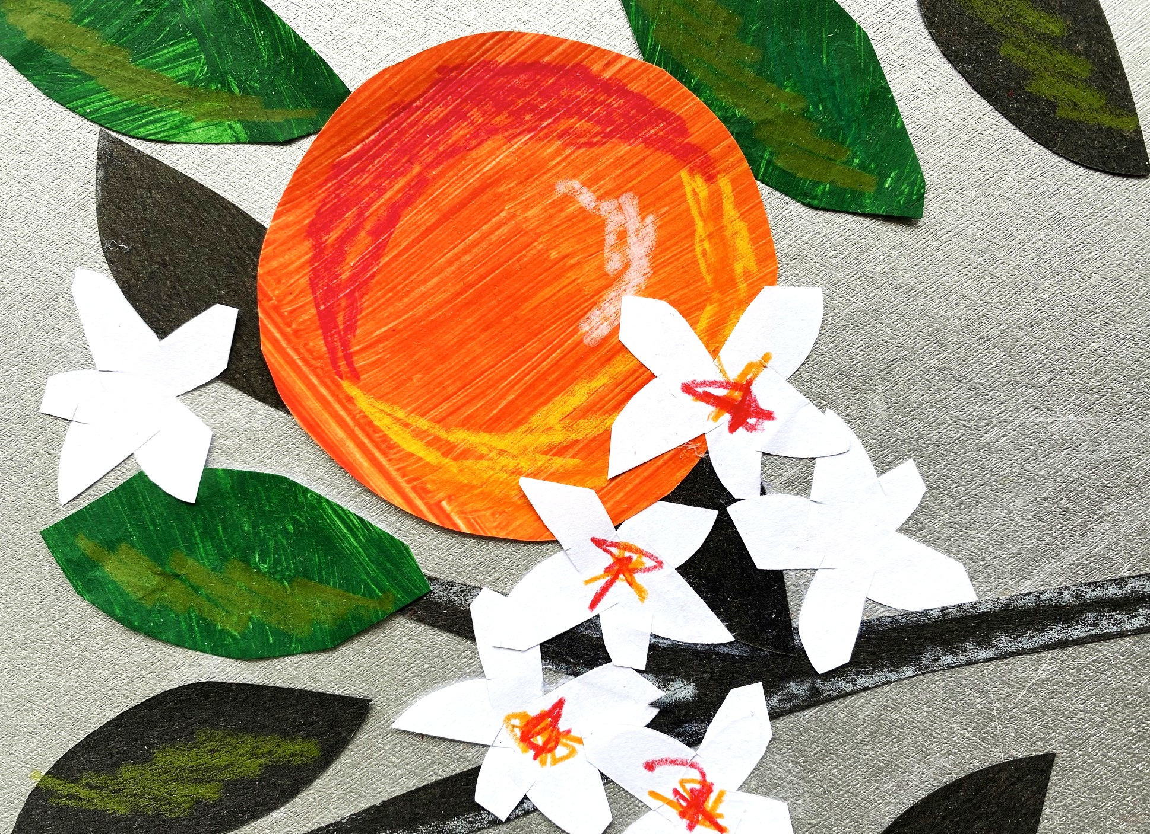
THURS Term1 TEXTILES.. T2 ART.. T3 POTTERY.. T4 ART
TUE Term1 ART.. T2 POTTERY.. T3 ART.. T4 POTTERY

AFTER SCHOOL CLASSES 2023

3pm to 4.30pm Tues &/or Thurs
Where – At school – Te Are (Green Room)
Cost - $179 term Ages - 5 -11yr Start – Feb 14th/16th

HOLIDAY WORKSHOPS
ART ALL DAY! 9 to 3pm, Pt Chev, $65pp
Please see website for dates.
Y O L A N D E L I G H T 0 2 7 4 2 3 0 1 7 3
y o l y @ h o l y m o l y . c o . n z
www.holymoly.co.nz
All enquiries go thru Yolande, not the school, many thanks.
A R T S & C R A F T S
H O L Y M O L Y

