 | 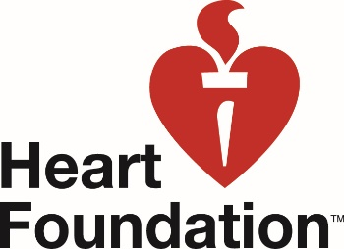 | 

Volunteer for the Heart Foundation at the Gazley Volkswagon Wellington Marathon 2020
The Heart Foundation is the official charity partner for the Wellington Marathon again for 2020. As part of this partnership we provide volunteers to work at the event, to raise money for the Heart Foundation Wellington Branch. We would love to have you join our volunteer team for this event. For 2020 we have the following opportunities:

Saturday 29 August: Race Registration, Gazley Volkswagon, Kent Terrace, Wellington
We will be registering all runners ahead of race day and handing out numbers. This role requires a high level of concentration and accuracy!
Full Day: 8.30am – 6.00pm includes lunch provided
Half Day: 8.30am – 1.30pm
Half Day: 1.00pm – 6.00pm

Sunday 30 August: Event Day, Sky Stadium
Jobs are a mixture of working in the recovery area (handing out drinks/fruit etc after the finish line, general support etc) and bag check area
Shift 1: 6.00am – 12.00pm
Shift 2: 7.00am – 1.00pm
Shift 3: 9.00am – 3.00pm

**************

Volunteer details:
- Name
- Email address
- Tel no
- Emergency person name and number
- Address

You can volunteer for as many days as you like. Please indicate your choices now:

I would like to volunteer for the following shift/s:

- Saturday 29 August: Race Registration Full Day: 8.30am – 6.00pm
- Saturday 29 August: Race Registration Half Day: 8.30am – 1.30pm
- Saturday 29 August: Race Registration Half Day: 1.00pm – 6.00pm

- Sunday 30 August: Event Day Shift 1: 6.00am – 12.00pm
- Sunday 30 August: Event Day Shift 2: 7.00am – 1.00pm
- Sunday 30 August: Event Day Shift 3: 9.00am – 3.00pm

Have you volunteered for the Heart Foundation before?

If not, would you like to be added to the Heart Foundation Wellington Branch volunteer list? This means that you will get to hear about any other volunteering opportunities that come up through the year.

Thank you for signing up to help at this year’s Wellington Marathon. You will hear from us very soon, in the meantime if you have any questions at all please contact: Annette Straugheir, Admin Assistant Wellington, 04 472 2780 ext. 1, annettes@heartfoundation.org.nz

