Newsletter Announcement - Information for Parents
We would like to announce the opportunity for our school community to use MathsBuddy. MathsBuddy enables students to control the pace of their own learning and further assists teachers to ensure that no-one misses out. This is because the key feature of this programme is that there is a
Video Tutorial for Every Mathematics Concept.
- To see what your child will experience go to www.mathsbuddy.co.nz

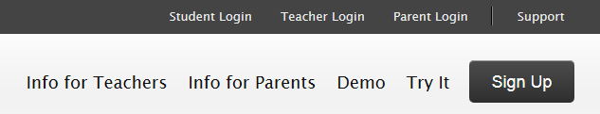

- Then ask for your child’s login details and insert them here
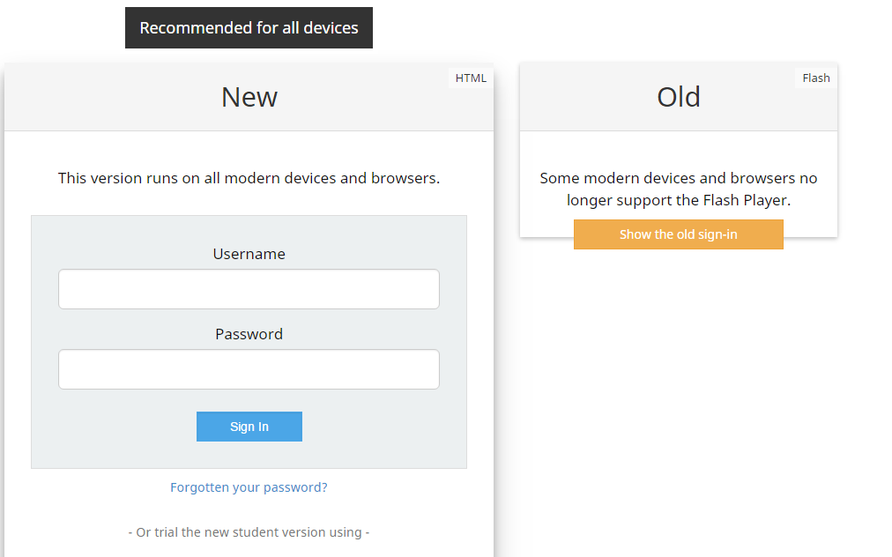
- Now you will have access to every lesson in the NZ curriculum from year 1 to 13 by selecting “Browse All Lessons”
