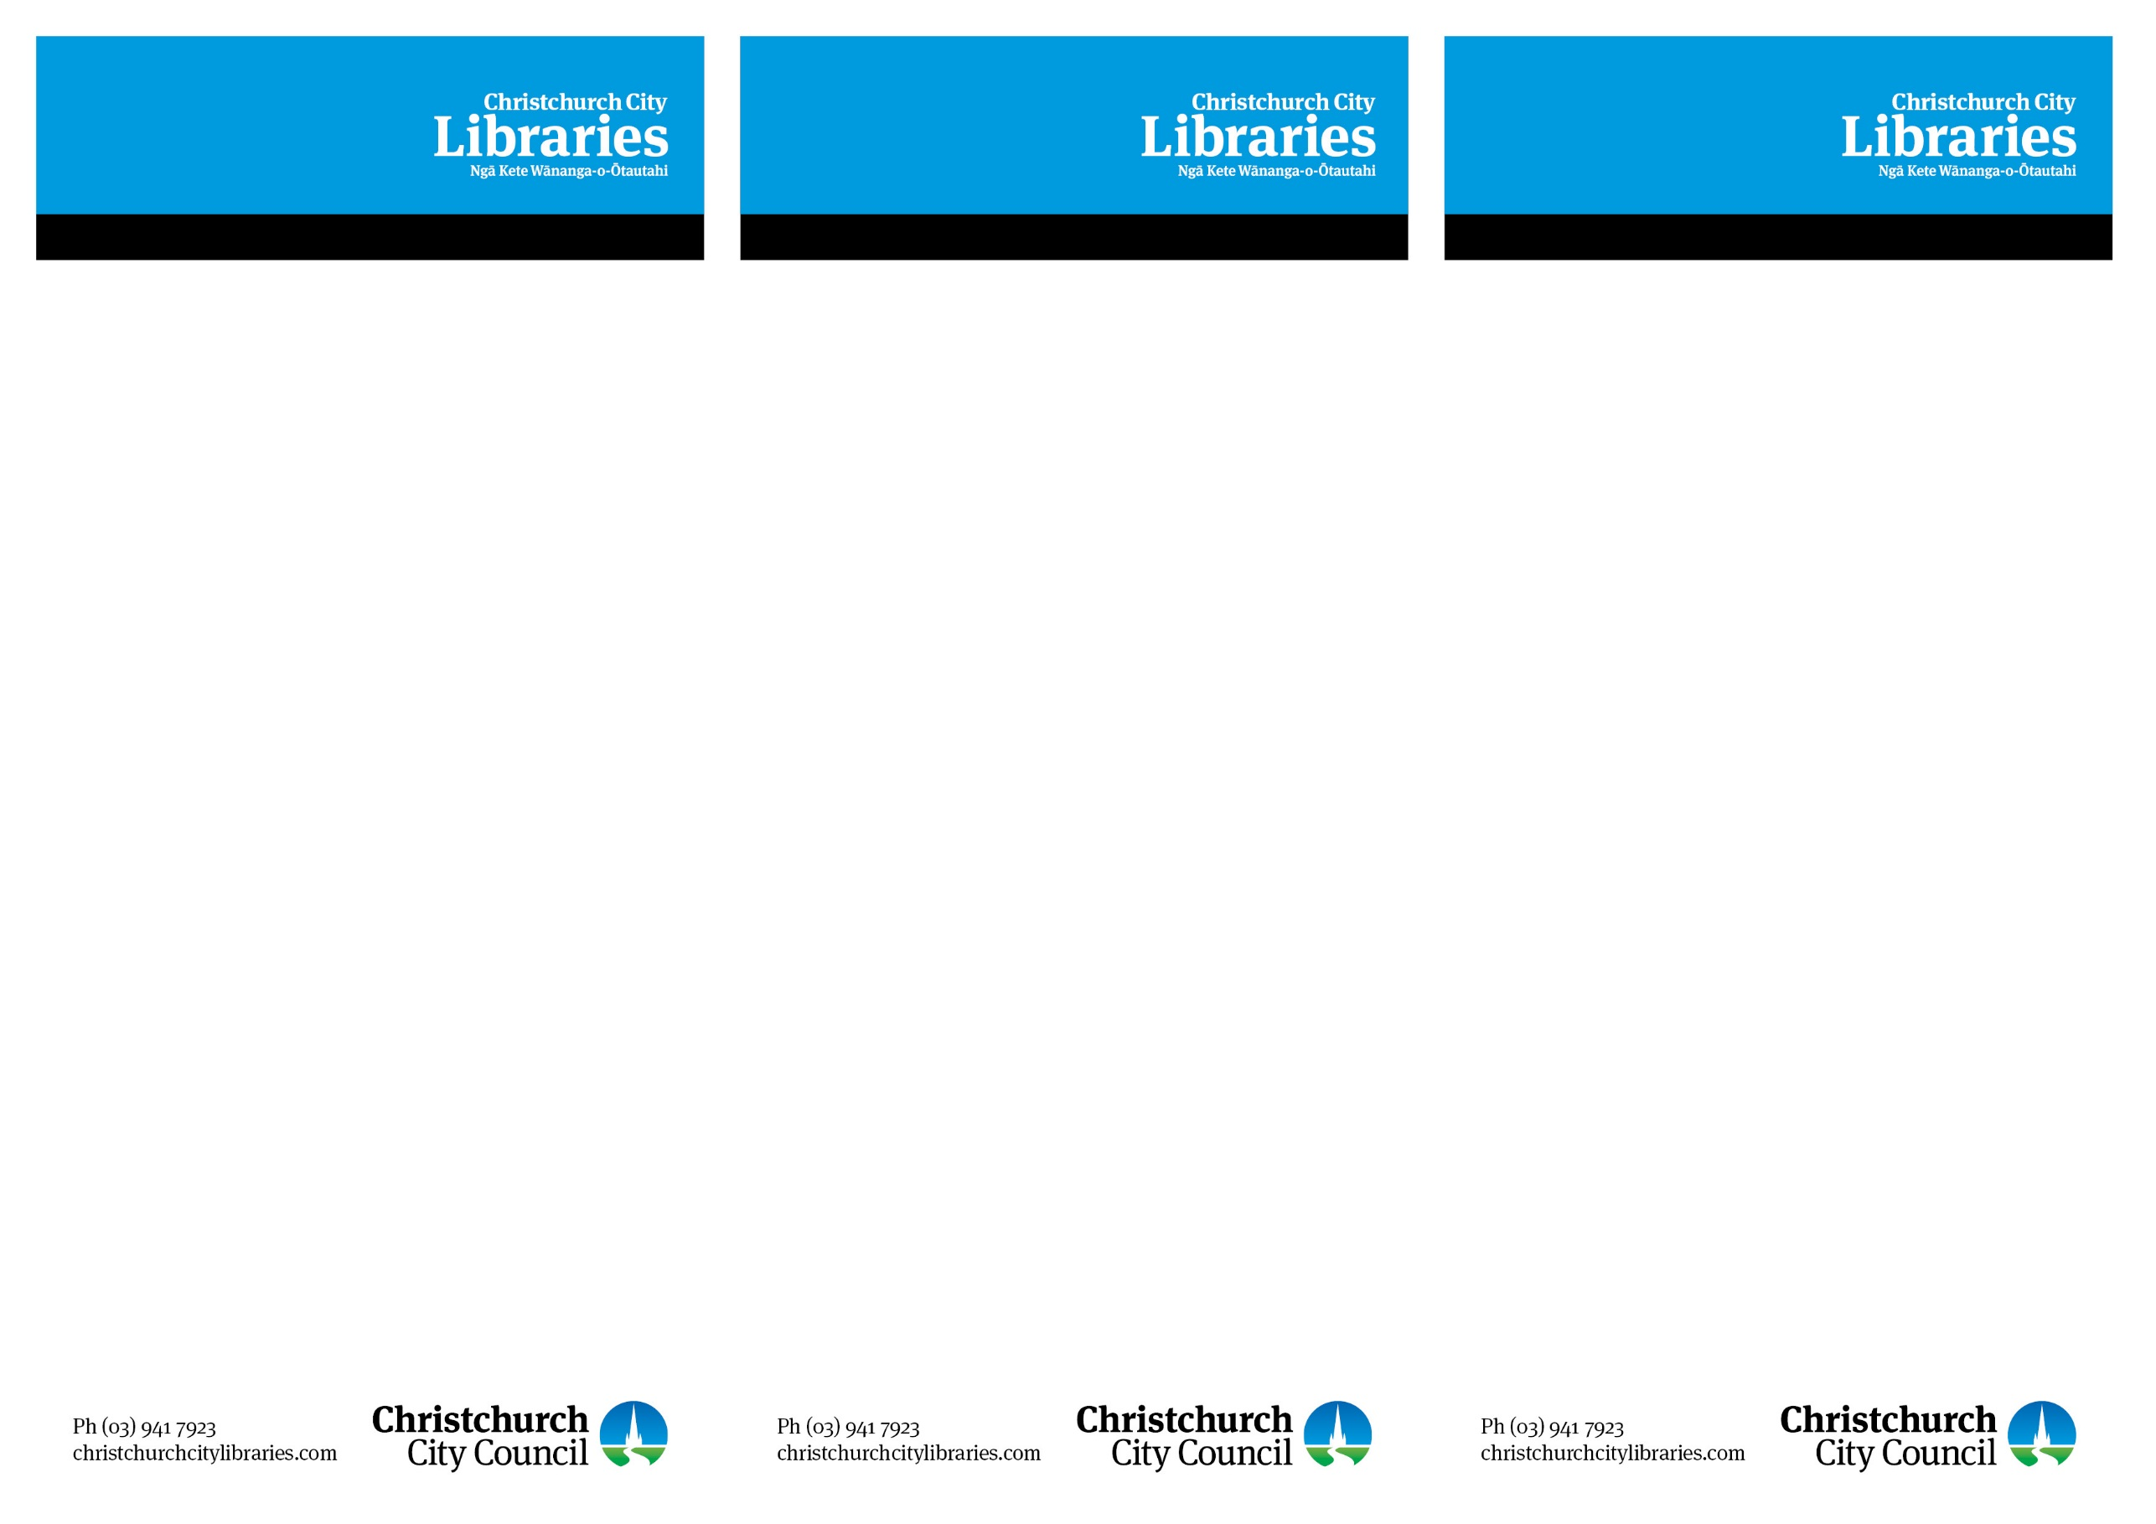

GenConnect

Connecting generations by sharing knowledge

- Questions about your iPad, Smart Phone or Tablet?
- Want to know how to use Skype, Facebook, or share your photos with family or friends?
- What is an app and which ones are the best ones to use?
Ask an “expert”!!

Come to Papanui Library where Papanui High School students will be available every Tuesday during term time from 12.10-12.40pm to help you find answers to all your questions!

GenConnect

Connecting generations by sharing knowledge

- Questions about your iPad, Smart Phone or Tablet?
- Want to know how to use Skype, Facebook, or share your photos with family or friends?
- What is an app and which ones are the best ones to use?
Ask an “expert”!!

Come to Papanui Library where Papanui High School students will be available every Tuesday during term time from 12.10-12.40pm to help you find answers to all your questions!

GenConnect

Connecting generations by sharing knowledge

- Questions about your iPad, Smart Phone or Tablet?
- Want to know how to use Skype, Facebook, or share your photos with family or friends?
- What is an app and which ones are the best ones to use?
Ask an “expert”!!

Come to Papanui Library where Papanui High School students will be available every Tuesday during term time from 12.10-12.40pm to help you find answers to all your questions!

