
Entertainment is the perfect gift for you or someone else.
Save heaps on dining, takeaways, retail outlets and activities.
Travelling these holidays?
Check out the deals on accommodation and car hire.
Upgrade to the Multi City for every NZ edition (& Australia/Bali) on the one APP.
Don’t forget that you can share Entertainment on up to 4 devices.
Until the end of January, we receive more towards our fundraising goal:
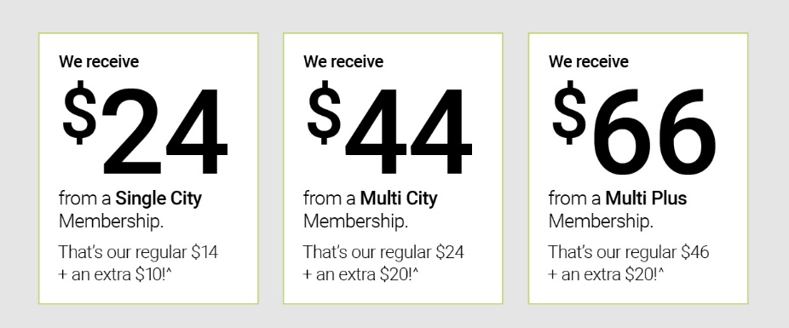
Buy your Entertainment Membership here and start saving:
https://www.entertainmentbook.co.nz/orderbooks/2601u57


