WAIMATE HIGH SCHOOL
SPORT LONG SLEEVE TEES – EXTRA CURRICULUM

This is the Waimate High School sports warm up top. These tops will be able to be worn by all students representing the school in any sporting code and is to be worn for sport only, it is not something that the students will be able to wear around school or for pe classes. The name on the back of the top will be the students surname only.

The material of these tops is 160gsm 100% breezeway polyester micro mesh fabric with sun protection and anti bacterial coating.

If you would like to order a Waimate High School sports warm up top, please complete the order form and return to the school office or email ncooney@waimate-high.school.nz with your details.

The cost for a warm up top is $42.50 and can be paid via the school office or online banking
Waimate High School BOT
02-0892-0087788-00
Part – Name
Ref – Warm Up Top

WAIMATE HIGH SCHOOL
SPORT LONG SLEEVE TEES – EXTRA CURRICULUM
ORDER FORM

Student Name: ______________________________________________________

Size: (Please Circle) Kids 8 10 12 14 16

Adults S M L XL 2XL 3XL 5XL

(Sample sizes are available through Nicole and can be tried on)

Cost: $42.50

Signature: __________________________________________________________

Contact Number: ____________________________ Date: ___________________

Sizing charts are below for specific measurements from the supplier.

Kids sizing
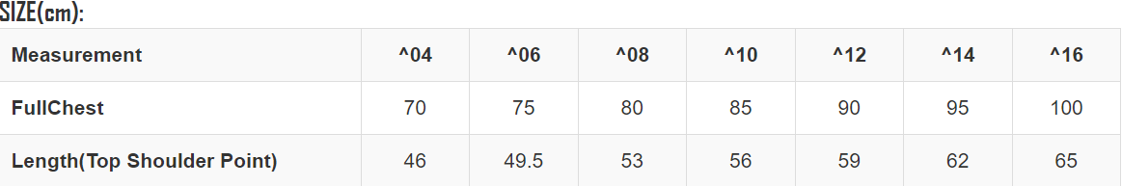

Adults sizing
