

Marshland School

Teaching Positions 2021

Application Package

Applications close 16th October 2020 at 3:00pm

Jacqui Pascoe

Principal

Dear Applicant

Thank you for your interest in the advertised teaching full time fixed term positions at Marshland School Te Rito Harakeke for 2021.

We have two positions currently in the Year 7 and 8 (Intermediate) area of the school. They are fixed term as a result of roll fluctuations, however there is continuing growth in our zone as a result of new subdivisions.

You will be working within team of 4 teachers and a teaching assistant with approximately 100 + students in a purpose built collaborative Learning Hub.

We are an increasingly diverse community and our programmes are underpinned by the values and principles our community hold dear through our learning model, the 7 principles of learning and the LEARN, CREATE, SHARE pedagogy of the Manaiakalani programme.

We are looking for passionate, innovative, caring teachers to join our teaching team. The successful applicants will be willing and able to work collaboratively with their team to follow the strategic direction of the school. They will be able to connect well with our parent/whānau community and contribute to providing all our learners with the best education using digital affordances at Marshland Te Rito Harakeke.

They will be team players and whole school focused.

If you believe you are the right person for this role, we look forward to hearing from you.

Please find enclosed:

* Information about Marshland School.
* An application form.
* Person Specification.
* Job Description.

Further information about Marshland School is available on our Website: [marshland.school.nz](http://marshland.school.nz/)

In making your application, please forward a covering letter explaining your suitability for the position. Be sure to make reference to the person specification and job description - we are looking for the right fit for our existing team. Add any area of the curriculum you consider to be a strength and that would add value to the whole school. Please give the contact details of 2 referees to further support your application.

**Applications to be received digitally:**

Email your application & EEO form to:

principal@marshland.school.nz

**About Our School**

Marshland School is a decile 9 co-educational full primary school, catering for students from Year 0 to 8. Our school is situated in a setting adjacent to the new Preston’s and Preston’s Park Subdivisions, and as such has been and will continue to be subject to significant growth. We have an enrolment scheme in place to manage the growth expected within the Preston’s Subdivision and the neighbouring Preston’s Park subdivision. Our opening roll in 2021 will be approximately 500, growing to approximately 540 by the end of 2021.

The school moved into its new site in January 2016. Our student roll has steadily increased since 2015 when it was around 200. Stages 1 and 2 of the school build enable us to cater for 500 students and Stage 3 (to be built in 2021) will give us the capacity for 610 + students. There are 6 learning Hubs including a satellite unit from Ferndale Specialist school. Each learning hub joins on to a large purpose built technology area or Maker space. Most of our learning hubs are configured as 2-year level groups within each hub. Teachers work collaboratively to meet children’s needs and all say they would now hate to go back to single cell teaching again.

We have middle to high socio-economic status. The community is predominantly Pakeha with a 15% Maori and Pacific Island, and 15% Asian and other. Our roll at the end of 2020 will be approximately 542.

We are richly resourced with Information Technology throughout the school and we run a very successful 1:1 device programme from years 5 to 8 where the students and teachers base their programmes around the Manaiakalani Model of Learn, Create, and Share pedagogy. We are in our third year of a 3 year involvement. This pedagogy is successful throughout the whole school whether they have 1:1 devices or not. Years 1 – 4 are very well resourced in terms of devices which the school provides.

Our learning model embraces **Learn, Create, Share** and our school values below:

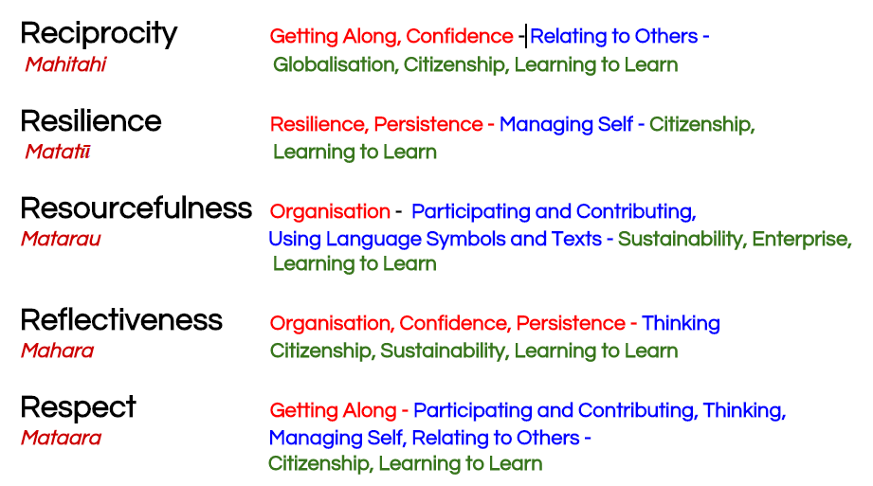

# 

# APPLICATION INSTRUCTIONS

If you wish to apply for the position, please send:

* Letter of application
* The completed application form
* Curriculum Vitae

To:

Principal Jacqui Pascoe

[principal@marshland.school.nz](mailto:principal@marshland.school.nz)

#### Application Closing Date:

The closing date for applications is 16th October 2020

**Estimated Timeline after Application Closing Date**

|  |  |
| --- | --- |
| 21 October 2020 | Short listed candidates contacted. These parties will be informed of the structure of the interview at this stage. |
| Week beginning 26th October 2020 | Interviews. The interview panel may consist of a range of board members and staff with the Principal |
| 23rd October 2020 | Successful applicants notified. |
| 28 January 2021 | Position starts. |

If you have any queries about the position, please contact the principal Jacqui Pascoe [principal@marshland.school.nz](mailto:principal@marshland.school.nz)

**JOB SPECIFICATION**

Marshland School offers an exciting opportunity for teachers who wish to extend their capability. Previous teaching experience is preferred.

* Works hard to ensure success for every child
* Displays strong curriculum knowledge and digital fluency, able to articulate learn, create share pedagogy
* Reflects on performance and applies personal learning
* Changes practice as the result of data to ensure the best for our tamariki
* Displays effective interpersonal behaviour, effectively communicates verbally and in writing with all stake holders
* Demonstrates resilience and perspective when things go wrong
* Displays cultural awareness and bi-cultural proficiency
* Is an excellent role model to others providing inspiration to tamariki
* Understands collaboration and is able to work collaboratively,
* Excellent organization and manages workload effectively
* Demonstrates digital proficiency and understands how to integrate this seamlessly into the curriculum, including the digital part of the technology Curriculum

**Person Specifications**

We are looking for teachers with:

* Excellent self-awareness and communication skills
* Ability to get on well with staff, parents and whānau
* Willingness to go the “extra mile” and add to the wider school community
* Successful teaching experience and experience working collaboratively
* High expectations for themselves and for all students
* The ability to manage behaviour in a positive strengths based way looking for solutions
* Culturally inclusive practices
* Committed to the success of all akonga within their team
* Strong digital curriculum knowledge and practice
* Love of learning

**APPLICATION FORM**

**Personal Details:**

|  |  |  |
| --- | --- | --- |
| Name |  | |
| Teacher Registration Number: |  | Provisional/ Full/ STC (circle one) |
| Address |  | |
| Home Phone: | Work Phone: | Mobile: |
| Email Address: |  | |
| Date of Birth: |  | |

**Current Employment**

|  |  |
| --- | --- |
| Name and address of school or place of employment: |  |
| Period of Employment: | From To |
| Position/s Held: |  |

**Employment History**

|  |  |  |
| --- | --- | --- |
| Name and address of employer | Position/s held | Dates |
|  |  |  |
|  |  |  |
|  |  |  |
|  |  |  |

**Medical Questionnaire**

Do you have any medical conditions that may affect your ability to effectively carry out the functions and responsibilities of employment, or which may be aggravated or further contributed to by the functions and responsibilities of employment?

#### Yes / No

If you have answered ‘yes’ to the above question, please provide details.

**Convictions against the law**

Have you ever been charged with or convicted of any criminal offence against the law or otherwise know of any reason why you should not be employed to work in the school environment?

#### Yes / No

If you answered yes, please provide the date and details of the offence, or other reasons, together with any comments you wish to make.

**Please note:** You may be requested to provide a copy of the relevant Court record(s), obtainable from the Registrar of the Court concerned. Failure to provide correct and true details of any conviction will make you liable to dismissal from the employment of the Board of Trustees should you be a successful applicant.

The Marshland School Board of Trustees may seek a police clearance from all short-listed applicants or preferred applicants, prior to the confirmation of appointment

## Referee Information

Please provide information for two referees. Referees must be known to you in a work related capacity.

Referees may be contacted for information at our discretion to help with short listing or clarifications of candidate suitability to proceed.

|  |  |
| --- | --- |
| Name: |  |
| Phone number: |  |
| Email address: |  |
| Professional relationship (where applicable): |  |

|  |  |
| --- | --- |
| Name: |  |
| Phone number: |  |
| Email address: |  |
| Professional relationship (where applicable): |  |

**Privacy Act**: I give permission for the selection panel to seek information about my employment and personal background, and I understand that this information will be treated in complete confidence.

|  |  |  |  |
| --- | --- | --- | --- |
| Proof of Identity | | | |
| To assist the school to meet the requirements for proof of identity, **applicants who are short-listed** are required to present two forms of identification from the list in the table below (one document from Category A and one document from Category B). At least one of the acceptable forms of identification must be photographic. The documents must be current, not expired, and issued by an authorized agency. If applicable, where names or other identity information on either identification documents (Category A and Category B) differ, please provide acceptable evidence (e.g. a marriage certificate or a statutory declaration). | | | |
| Category A | Tick | Category B | Tick |
| New Zealand passport |  | New Zealand Driver License |  |
| NZ Certificate of Identity issued under the Passports Act 1992 to non-New Zealand citizens who cannot obtain a passport from their country of origin |  | 18+ card |  |
| New Zealand Certificate of Identity (issued to people with refugee status) |  | Community Services Card |  |
| New Zealand Refugee Travel Document |  | Super Gold Card |  |
| Emergency Travel Document |  | Inland Revenue Number |  |
| New Zealand Firearms License |  | Electoral Roll Records |  |
| Overseas Passport (with or without NZ Immigration visa/permit |  | New Zealand issued utility bill (issued not more than 6 months earlier) |  |
| New Zealand full birth certificate (issued on or after 1998) |  |  |  |
| New Zealand Citizenship Certificate |  |  |  |

EQUAL EMPLOYMENT OPPORTUNITIES FORM

This sheet is for E.E.O. information only. It will be removed before the panel considers your application.

Gender: ___________________________

Date of Birth: ___________________________

Ethnic Origin (Please tick one or two items from the list below)

New Zealand European

New Zealand Maori

Samoan

Cook Island Maori

Tongan

Chinese

Indian

Niuean

Tokelauan

Fijian

Other European (such as English, Australian, Scottish, Dutch)

(Please state) ____________________________________________

Other ethnic groups (such as Vietnamese)

(Please state) ____________________________________________

.