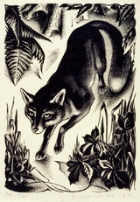
Fox
Agnes Miller Parker

Fox

The Marble fox stalked a glowing silver rabbit
among the dull ferns and reeds in the woods
the fox moved his black paws silently among dead leaves and moss
the paws red with blood
the paws that had killed
and would again

He raced down a dark path after the light
as he continued his chase
happiness pulled at the sadness that clouded his heart
and for a second he felt warm
and then the rabbit’s light lost its glow

The rabbit had gone and the light faded
The fox dropped the limp body that had been consumed by the darkness
and went in search of another piece of light
to make the cold go away again

By Phoenix Holswich

