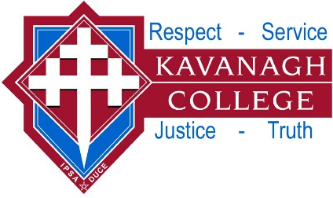
KAVANAGH COLLEGE BASKETBALL DRAW

Friday 11 August

The full draw can be viewed at http://drawsresults.sportsrunner.net/

Team: Opponent: Venue: Time: Duty:

Senior Boys Blue vs Kings Blue Court 3 8:00pm

Senior Boys Red vs South Otago Court 6 6:00pm

Senior Boys White vs Kings Amigos Kavanagh 6:15pm

Junior Boys Blue vs JMC Jnr A Court 3 4:00pm

Junior Boys Red vs JMC Razor Backs Court 7 5:00pm

Senior Girls Blue vs St Hildas Court 2 8:00pm

Senior Girls Red vs Columba CC Ballers Columba 7:15pm

Senior Girls White vs St Hildas Sharks Kavanagh 5:15pm

Junior Girls Blue vs Kava Jun Girls Red Court 1 4:00pm

Junior Girls Red vs Kava Jun Girls Blue Court 1 4:00pm

Notes:
- Good luck to all teams.

Any questions see Mr Waterworth.

