

OSCAR @ Oaklands

Oscar at Oaklands offers a fun, safe environment for your children in the July School Holidays..
We are located in the school grounds and are open 7am-6pm. Some activities we are doing, are bowling, chipmunks, inflatarun, cheese rolls, clay fun bunting. So come join us for some fun
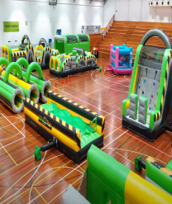
Follow the link below to enrol your children now: https://enrolmy.com/oscar-at-oaklands/book-now/29-Oscar-at-Oaklands---July-2021---Holiday-Program
(MSD subsidy available for those who qualify)

