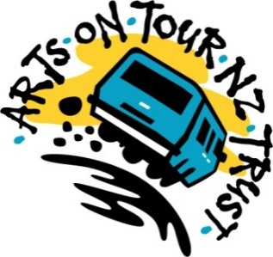

For immediate release

31 May – 2 July 2023
A national Arts on Tour NZ Tour
Jackie goes Prima Diva

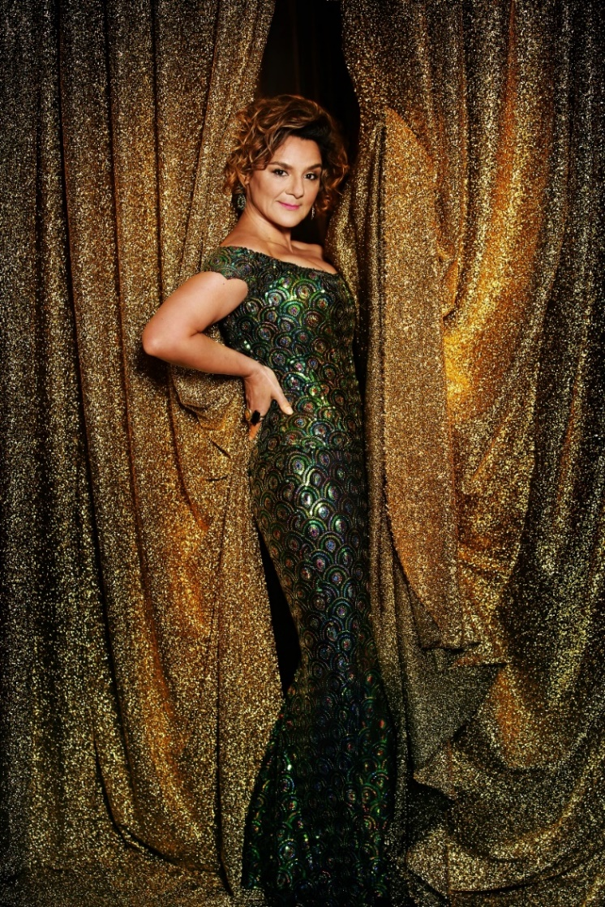

Clarke is a gem, an absolute natural on stage with her comic timing, asides and most of all, her outstanding voice – Patrick Shepherd, Christchurch Symphony Orchestra - Fresh Sounds review, Christchurch Star.

This self-styled “Pacifica Rita Hayworth, with a touch of Spotlight” really knows how to entertain (and did I mention she can really sing?)….the hall could have been Carnegie or Royal Albert, but was in fact the Twyford Community (Hall)! She would do either of those stages proud also - Rob Harbers, Ambient Light Blog review, Hawkes Bay Festival 2022

Homegrown chanteuse Jackie Clarke turns her powerhouse vocals, wicked humour and maverick entertainment style to interpret the songs of the 20th and 21st Centuries most legendary divas.

Ms Clarke pays homage to Judy Garland, Shirley Bassey, Peggy Lee, Barbra Streisand and more! From Alberta Hunter to Dolly Parton, from Kate Bush to Lady Gaga, Jackie lets her diva flag fly, while playfully interacting with the audience with trademark witty panache.

Accompanied by her trusty sidekick Maestro on piano, expect iconic songs performed with tender soul and gleeful virtuosity.

In 2018 Jackie Clarke was awarded an MNZM for services to entertainment; 40 years treading the boards in theatre, (Mamma Mia, Shirley Valentine) music (When The Cat’s Been Spayed, The Lady Killers) and T.V. (NZ Idol).

Don’t miss this rollicking show of bravura song styling, dazzling frockage, pin-drop moments and plenty of laughs from a NZ dairy-fed Diva with her feet on the ground and her head amongst the stars.

Jackie Clarke MNZM

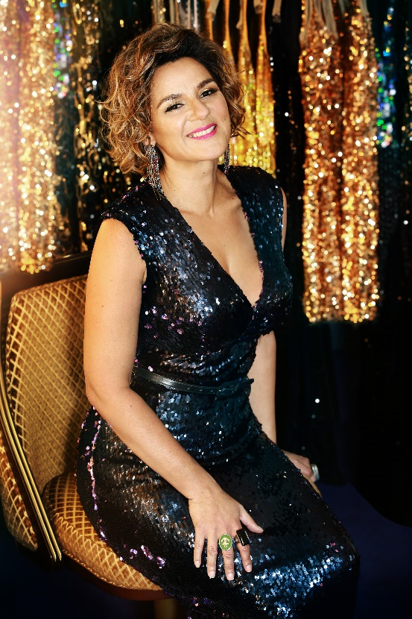
Jackie Clarke was recognised in 2018 with an MNZM for services to the entertainment industry. Most recently she starred in the one-woman play Shirley Valentine, performed Jackie Goes Prima Diva at the 2022 Hawkes Bay Arts Festival, devised/produced & premiered Rock Follies Forever, with Jennifer Ward-Lealand & Laura Daniel, and performed a series of successful concerts with opera tenor Simon O’Neill and musical theatre baritone Tim Beveridge.

Ms Clarke co-founded pop-comedy group When The Cat’s Been Spayed, releasing two albums and touring for ten years. She’s one-third of The Lady Killers alongside Tina Cross and Suzanne Lynch and as a soloist she's worked with artists such as Sir Dave Dobbyn, Annie Crummer, Greg Johnson and Simon O'Neill.

On stage Jackie has starred in Joseph & the Amazing Technicolour Dreamcoat, Mamma Mia, Anything Goes, Sweet Charity and Once, as well as NZ works The Underwatermelon Man, C The Musical & Dominion Road the Musical.

She has performed with all of New Zealand’s orchestras and been part of Jubilation for 20 years.

Television work includes judging NZ Idol, guesting on the Jacquie Brown Diaries and presenting several documentaries.

Grant Winterburn – on tour from 4 June onwards

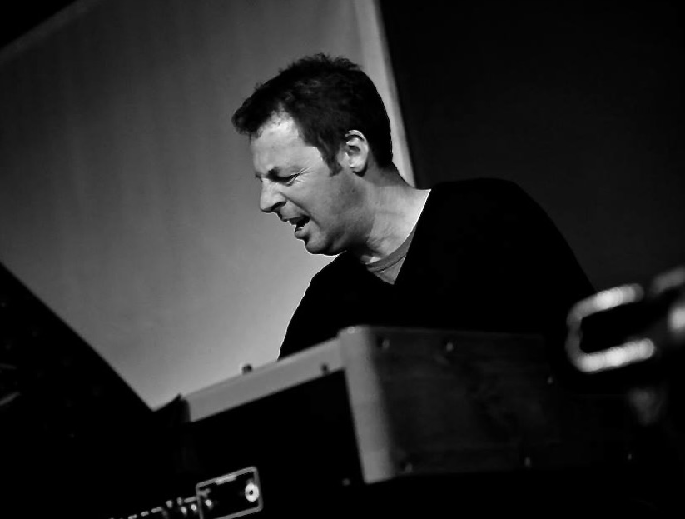
With more than 35 years of experience as a musician Grant’s career has covered a vast array of musical situations - some of them more dangerous than others! This rich journey in live music has involved being a musical director, pianist, accompanist, jazz organist, rock musician and teacher.

As a musical director Grant has worked on many theatre productions including: Shortland Street the Musical, Cabaret, The 25th Annual Putnam County Spelling Bee and The Rocky Horror Show for Auckland Theatre Company, Assassins and The Threepenny Opera for Silo Theatre, The Pirates of Penzance and RENT.

As a session musician he has performed with The Lady Killers, (Jackie Clarke, Tina Cross, Suzanne Lynch), Jennifer Ward-Lealand, Richard O’Brien, Geoff Sewell, Midge Marsden, Carly Binding, Eye TV, the Neutrino Funk Experience to name but a few and played keys on shows such as Priscilla Queen of the Desert, Coca Cola Christmas in the Park, New Zealand’s Got Talent, Stars in their Eyes, Mamma Mia, Jersey Boys, Cats, Anything Goes and Avenue Q.

Grant can be regularly seen as a pianist with Operatunity music travel throughout NZ and overseas.
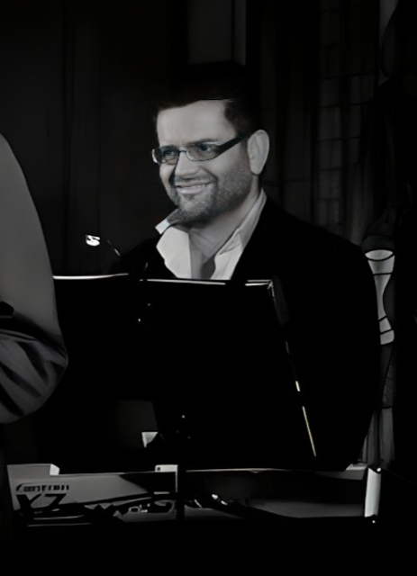
Karl Benton – on tour 31 May to 3 June

Karl Benton has worked in the New Zealand music industry as an educator, performer and creative for over thirty years. He has extensive experience in many fields including studio recording, band arranging, musical direction, touring, teaching, artist mentoring and working for iconic and respected local artists. He has been a music educator for many years, both in private and institutional contexts (MAINZ, Excel School of Performing Arts). Karl’s broad experience in the music industry has seen him represent New Zealand as a musician many times overseas and performed and toured numerous times with iconic New Zealand artists such as Kantuta, Ardijah, Lizzie Marvelly, Che Fu, Jackie Clarke, Rikki Morris, Sir John Rowles, Annie Crummer, and many more.

Itinerary

www.aotnz.co.nz
https://www.eventfinda.co.nz/tour/2023/jackie-goes-prima-diva-tour

Wednesday 31 May 7:30pm Matamata
Matamata Little Theatre, 5 Short Street
$25 Tickets: www.mds.org.nz

Friday 2 June 8:00pm Norsewood
The Old Dairy Factory
$99 includes ticket and two course meal
First course at 7pm the show starts at 8pm
Tickets: https://www.undertheradar.co.nz/gig/83034/Jackie-Clarke.utr

Saturday 3 June 7:30pm Pohangina
Pohangina Hall
$35 tickets.pohanginavalley.nz

Sunday 4 June 8:00pm Upper Hutt
Whirinaki Whare Taonga
$20 Tickets: www.whirinakiarts.org.nz

Tuesday 6 June 7:30pm Picton
Picton Little Theatre
$25 Tickets: Eventfinda and Summit Real Estate

Wednesday 7 June 7:30pm Nelson
Nelson Centre of Musical Arts
Admission $35; Earlybird $25 ends 14 April
https://nz.patronbase.com/_NelsonCentreOfMusicalArts/Productions/JKCL/Performances
Thursday 8 June 7:30pm Motueka
Chanel Arts Centre
$25 Adult; $5 School Children
Tickets: Floral Affaire, High Street, Motueka (cash only); Door Sales (EFTPOS available)

Friday 9 June 8:00pm Reefton
Reefton Club
$25 Door Sales or PH. (03)7328542
Sponsors: ROSCO CONTRACTORS LTD

Saturday 10 June 7:30pm Balcairn
Balcairn Hall
$30 Tickets: Sally Mac's, Amberley; Sefton Garage; Stan's 7 Day Pharmacy, Rangiora; www.balcairnhall.com

Sunday 11 June 2:00pm Ashburton
Ashburton Event Centre
$25 Tickets: http://ateventcentre.co.nz/

Tuesday 13 June 7:30pm Cromwell
Coronation Hall, Bannockburn
Tickets: artscentral.co.nz

Wednesday 14 June 7:00pm Roxburgh
Roxburgh Town Hall
$25 Tickets: iSite

Thursday 15 June 7:30pm Waikaia
The Lodge 223
$25 Tickets: www.thelodge223.co.nz

Friday 16 June 7:30pm Invercargill
Civic Theatre
$45 ticketek.co.nz

Saturday 17 June 7:30pm Dunedin
Regent Theatre - Clarkson Studio
$30 Adult; $25 Concession; $15 Child; $160 Studio Package
https://www.regenttheatre.co.nz/project/studio-series-jackie-goes-prima-diva-june-17-2023/

Sunday 18 June 7:30pm Geraldine
The Lodge Theatre
$30 Tickets: Louk Clothing, Talbot Street

Tuesday 20 June 7:30pm Akaroa
The Gaiety
$25 Tickets: The Akaroa Museum & The Good Story Book Shop
This is a glam affair. Think pearls and diamonds!

Sunday 25 June 7:00pm Whanganui
Whanganui War Memorial Centre, Concert Chamber
$25 Tickets: Royal Whanganui Opera House - Box Office

Wednesday 28 June 7:30pm Rotorua
Shambles Theatre, Amohau Street
$30 Tickets: 07 347 6275

Thursday 29 June 7:30pm Whakatane
The Baptist Church, Keepa Road
$40 Presale; $45 at the Door; $20 Student
Tickets: Eventbrite and The Good Life, The Strand

Friday 30 June 7:00pm Putaruru
The Plaza Theatre
$15 Tickets: The Plaza Theatre

Saturday 1 July 7:30pm Hamilton
The Meteor Theatre
GA $35; Conc $27
Tickets: www.themeteor.co.nz

Sunday 2 July 6:00pm Pukekohe
Harrington Theatre
$35 Tickets: www.trybooking.com

ARTS ON TOUR NZ (AOTNZ) organises tours of outstanding New Zealand performers to rural and smaller centres in New Zealand. The trust receives funding from Creative New Zealand as well as support from Central Lakes Trust, Community Trust South, Interislander, Otago Community Trust, Aotearoa Gaming Trust, West Coast Community Trust, Pub Charity and Community Trust Mid and South Canterbury. AOTNZ liaises with local arts councils, repertory theatres and community groups to bring the best of musical and theatrical talent to country districts. The AOTNZ programme is environmentally sustainable – artists travel to their audiences rather than the reverse. www.aotnz.co.nz

For information, interviews and images please contact:
Lorraine Steele, AOTNZ media liaison, 021 859 805 lorraine@lighthousepr.co.nz

