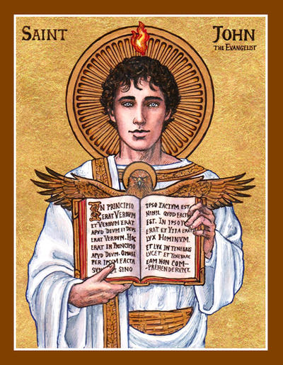

Are we preparing the way A time to reflect

An advent retreat

Led by Steven Benford
Bishop of Dunedin

Saturday November 25th 10am till 4pm
St Margaret’s Anglican Church Brighton
4 Seaview Terrace Brighton

numbers limited so please book your space with
Maureen Harley at maugernz@gmail.com

Koha to cover costs would be appreciated.

