ZONES of Regulation School-wide Programme

As you will have previously read in our newsletter, as a school, we have started the ZONES of Regulation programme to give our tamariki the opportunity to learn how to regulate their emotions. We thought it was important to update and share with you the new language and strategies taught in all classrooms to date.

The purpose of the first two lessons:
- introduce the programme
- increase vocabulary around emotions; and
- recognise different facial expressions.

Each classroom created a display and discussed how, when they understand how they are feeling, they are better able to control themselves. At this stage, even if they don’t have the tools to do something about it, at least they can tell others how they are feeling using a common language.

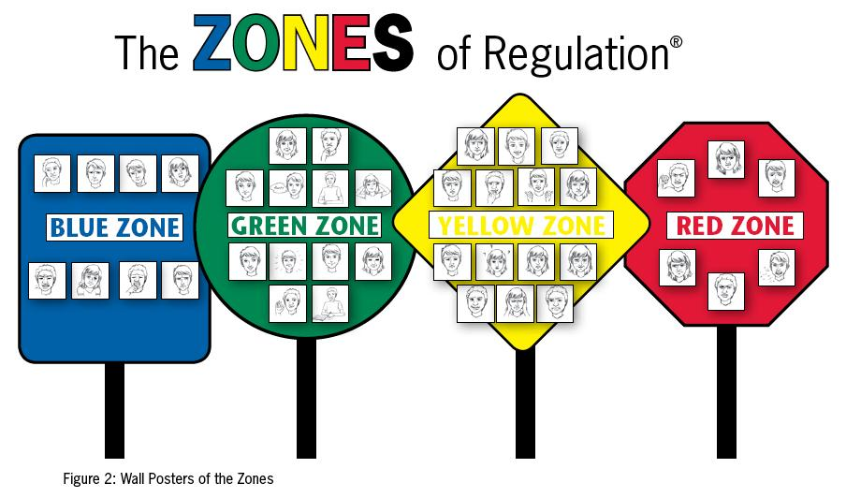

Blue Zone: sick, tired, sad, bored, moving slowly
Green Zone: happy, calm, good to go, focused, ready to learn
Yellow Zone: frustrated, worried, silly/wiggly, anxious, excited
Red Zone: mad/angry, mean, yelling/hitting, out of control, I need time and space

Discussion with whānau
You may want to emphasise that a facial expression is a clue to what a person is thinking or feeling. “How could reading someone’s facial expression change how you interact with that person?”

