OUTDOOR ADVENTURE
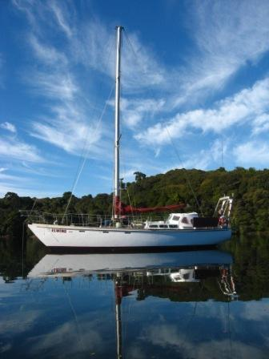
STEWART ISLAND

12 to 18 DECEMBER 2019

Open to all 2019 Year 13, School Leavers

YOUR Cost - $100 for the week.

. FOR MORE INFORMATION .

.. info.omct@xtra.co.nz or Ph (03) 454 2533 .
or your Year 13 Dean or Form Teacher
. or Contact your Local Masonic Lodge .

An experience of a Lifetime

Elwing Discoveries; In Association with The Otago Masonic Charitable Trust

