

**Theatre for Children Inc**

Presents:

**“The Pied Piper”**

**Written By Rob Ormsby**

**Directed By Amalia Calder**

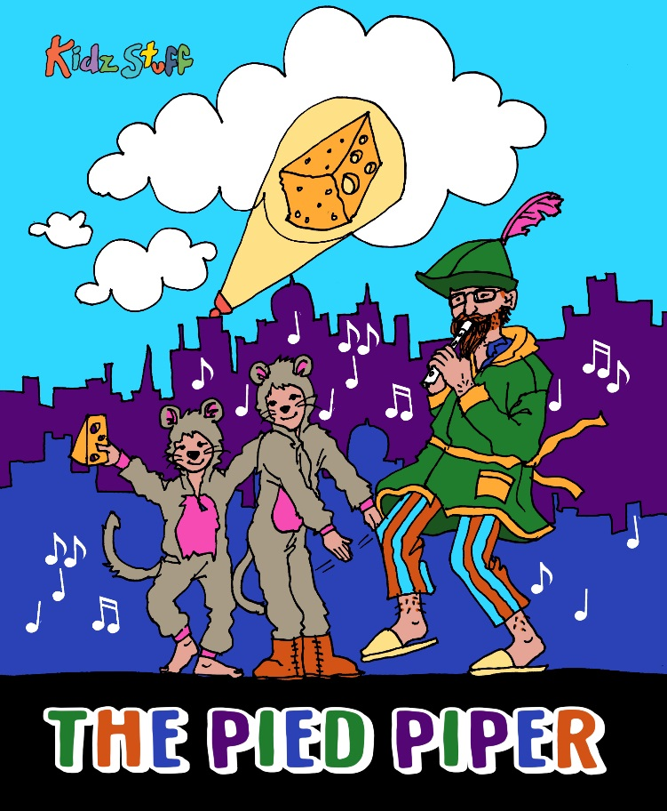

The Pied Piper is an exciting New Zealand

revival of an old German legend, sprinkled with songs and KidzStuff’s magic touch.

Are you ready to come along for a ride this spring and enter the imaginary world of Abby, Marco and their Dad?

Dad is a very good story teller, his tales are full of greedy characters, silly characters, forgetful characters and funny ratty type characters. Not to mention: Darth pirate, Candy the sugarfree fairy and The Pied Piper himself.

So get out your Flutes and head along to the Tararua Tramping Club, to see what The Pied Piper and his rattus ratties have in store.

**When: 30th September - 11th October 2019.**

**Monday - Friday 10am & 11:30am**

**10am shows only on Saturdays!**

**Tickets $10.50 pp**, **Children under 2 Free**

**$7 Special Preview, Saturday 28th August 2019**

**Bookings:**[**www.kidzstufftheatre.co.nz**](http://www.kidzstufftheatre.co.nz)

Contact: Amalia Calder

027 271 7351 / [kidzstuffnz@gmail.com](mailto:kidzstuffnz@gmail.com)

Media Release: For Immediate Release