
On Sunday 26 November, we'll be bringing Cantabrians together to celebrate our region while raising money for charity and enjoying costumes, music, fun and surprises from the starting line at New Brighton to the finisher's party at Redcliffs.
With awesome finish line activities, entertainment, great value team packages, and the NEW kids 1.5km Dash, Duck and Dive course, this year's event is going to be the biggest, brightest and most exciting yet.
Get in before 22 September to secure you Early Bird entry price!
Adults - $20.00
Kids (10-15yrs) - $10.00
Kids (9 & under) - $5.00
Family Passes - available from $40.00
A portion of all entries will be donated to our official charity St John.
Run for your school and raise money per KM
You can earn dollars for CTK school simply by entering! The school will receive 50c per KM for every person from the school community that joins the school team and participates in the ASB Summer Starter. From students to staff, to parents and grandparents - even the family dog! Ensure your kids are supporting CTK school by entering!

CTKSchool Page – click on the direct link below to register
https://secure.tiktok.biz/register/default.aspx?EventID=summerstarter&Edition=2017&Team=CTKSchool

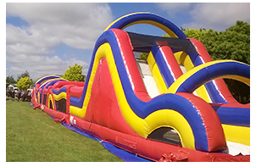
NEW Kids' Dash, duck and dive - presented by Garmin!
The kids' Dash, duck and dive presented by Garmin - our new fun and dynamic 1.5km course - brings a whole new level of excitement to kids fun runs! It even includes a giant inflatable obstacle in the course!

Entertainment and Finishers' party
Both the 4km and 10km courses will be scattered with musical surprises, entertainment and sweet beats aaaaaall the way from the starts to finishers' party.

For all of the details on ASB Summer Starter 2017, check out the website
summerstarter.co.nz

