18 April 2018

|  |
| --- |
|  |

**PROPOSED SAFETY IMPROVEMENTS TO SHETLAND ST/NAIRN ST INTERSECTION**

We are planning intersection safety improvements in a number of locations throughout the city and have selected the Shetland St/ Nairn St intersection as one of the first sites to trial a “mini” roundabout.

Roundabouts are an excellent option to better control traffic movements and speeds at intersections and have a good safety record. **All** approaches to the roundabout have to give way which makes it safer for pedestrians to cross the street at the intersection. This particular treatment will also be trialled at other locations throughout the city. The roundabout will be constructed using paint markings and plastic bollards. Monitoring and assessment of the performance will be done during this trial. Subsequently, a decision will be made whether or not to make these changes permanent and further consultation will be done during that stage.

A plan of the roundabout is shown below:-

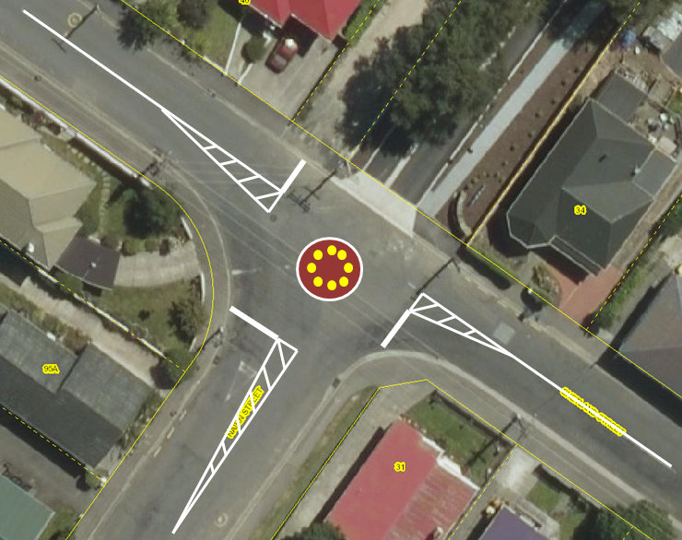

Inner circle of bollards to stop vehicles cutting across the roundabout

NAIRN ST

SUMMERSET VILLAGE

SHETLAND ST

If you have any comments on the proposal, please email or write to me by Monday 14 May 2018.

Yours faithfully



Ian Martin

**Transport Engineer**

transportation.safety@dcc.govt.nz