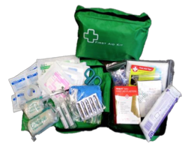

$39.00

**Medium Soft First Aid Pack**

Zip up Carry Case with transparent fold out compartments (250mm=Width x 190mm=Height x 90mm=Depth)

CPR Face Shield with one way valve

Sterile Sealed Edge Eye Pad

Sterile 5cm x 7.5cm Non Adherent Dressing

Sterile 10cm x 7.5cm Non Adherent Dressing

5cm x 4.5M Stretchy Cotton Crepe Bandage

7.5cm x 4.5M Stretchy Cotton Crepe Bandage

Sterile Medium Wound Dressing

Sterile Triangular Bandage

Pack 5x Splinter Probes

15ml Saline Irrigation Ampules

25mm Roll Clear Easy Tear Medical Tape

Pack 50x Skin tone, H2O Resistant, Breathable Island Dressing, Latex Free-Plasters

Sterile Non-Woven Gauze Swabs (2’s)

Rescue Shears (Scissors)

Steel Tweezers

Medical Grade Nitrile Gloves

Pack 10x Safety Pins

190mm x 110mm Antiseptic Towelettes

Emergency Foil Blanket

First Aid Tips

Contaminant Bag

Aids/Hepatitis Warning Label