**Kavanagh College Senior A/B**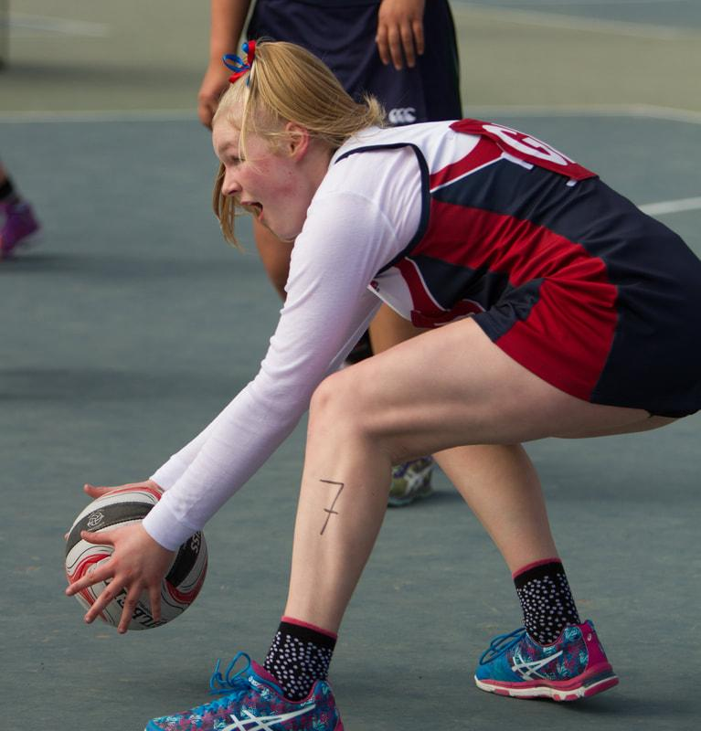

**Preseason Netball Trainings 2018:**

Information to all interested in trialling for the

Senior A/B team

Each year we start the Netball season off with 3 x preseason sessions to dust off the cobwebs and to get back out on court to prepare yourself for the season and trials ahead.

If you are wanting to trial/play in the Senior A/B team **you are required to attend all 3 preseason sessions** to your show your commitment and dedication to wanting to be a part of these teams.

Throughout the season the Senior A and B team will have a club night which is a fitness based session and will be on **Tuesday nights** at the Edgar centre and the team training on a **Thursday night** at the Edgar Centre(times to be confirmed).

**Preseason Session #1: 4.30pm-6pm on Thursday the 15th of February**

**Preseason Session #2: 4.30pm-6pm on Thursday the 22nd of February**

**Preseason Session # 3: 4.30pm-6pm on Thursday the 1st of March**

**Trial # 1: 4.30-6pm on Thursday the 8th of March**

**Trial # 2: 4.30-6pm on Tuesday the 13th of March**

**All preseason sessions and trials to be held on the Kavanagh**

**courts or in the gym if it’s wet.**

There will be selectors at all of these preseason sessions to make sure you all have a fair amount of time to show your skills. There will be a trial sheet at preseason sessions so you can write down your name and preferred playing positions before the netball trials.

Thanks and if you have any questions please come and see me in the Sports Office.

Regards,

Anita Van den Beld