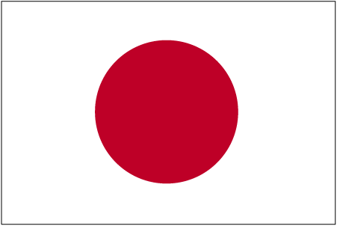


Permission Slip

I give permission for my child________________________________ to apply for the sister city Exchange to Eniwa, Japan & acknowledge:

- Applicants will need a current passport.

- I understand my son or daughter will be home-hosted while in Eniwa.

- Approx airfare cost to the student $3000 + taxes and optional personal spending ($250-500) which will need to be paid Jan /Feb 2019 to take advantage of the cheaper flights.

- Students shortlisted will be contacted by the Sister Cities Committee for an interview at end of November or early December 2018.

Signed: ___________________________________________________

Relationship to the applicant: ___________________________________

Parents names:__________________________________________________

Phone Number:_________________________________________________

Email:________________________________________________________

Would it be possible for you to reciprocate and host an Eniwa Student for 3 weeks when their exchange students visit (in March 2019)? (This has no bearing on whether your child is successful or not.)

yes / no

