

**Theatre for Children Inc**

Presents:

**Pirates vs Ninjas**

(vs The Evil Vampire Wizards)

**Written By Russell King**

**Directed By Amalia Calder**

**Starring: Charlie Potter, Maddie Brooks Gillespie, Tara Given, Tom Kereama**

KidzStuff brings ye some piratey fun these April School Holidays. Arrrrgggghhh me hearties! The Captain's magic socks have been stolen by a Ninja! These magic socks are the Captain's most treasured treasure. Can you venture on the seven seas and help us track down this scurvy nave of a Ninja? Grab ye pirate hat and best eye patch and join us for Pirates Vs Ninjas!

Tom Kereama from Wellington and Maddie Brooks Gillespie, originally from Australia, now residing in Newtown, return from our highly successful season of The Pied Piper in 2019. This time they both get to be pirates! You may also recognize Tom from playing multiple characters in Badjelly the Witch. Tom is also regularly seen performing around Wellington and was most recently seen playing Shakespeare’s King John in the New Zealand Fringe Festival. Maddie has been a long standing and very proactive member of Shakespeare Globe Centre New Zealand. At the tender age of only 18, she has already worked for most of Wellington’s professional theatres, as well as being chosen to perform and learn at the Globe Theatre in London.

Charlie Potter and Tara Given are both new to KidzStuff, and bring plenty of talent, experience, and lovely singing voices. Charlie, originally from the UK has performed Children’s Theatre in Europe and Tara, originally from the Waikato, recently toured the Cat in the Hat throughout NZ and Australia.

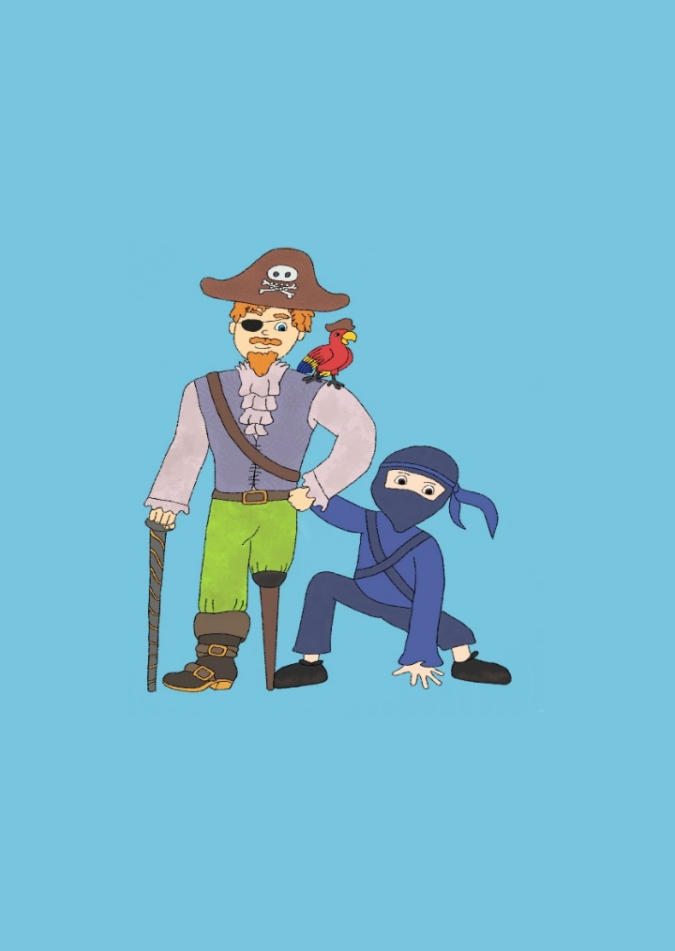

**When: 16th – 29th April 2022**

**Monday - Friday 10am & 11:30am**

**10am shows only on Saturdays!**

**Tickets $12.50 pp**, **Children under 2 Free**

**$7 Special Preview, Saturday 16th April 2022 Bookings:**[**www.kidzstufftheatre.co.nz**](http://www.kidzstufftheatre.co.nz)

Contact: Amalia Calder

027 271 7351 / [kidzstuffnz@gmail.com](mailto:kidzstuffnz@gmail.com)

Media Release: For Immediate Release