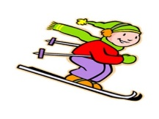

SKI TRIP – Round Hill
Monday 5th Sept 2022

Dear Parents
Our ski trip this year will be held on the Monday 5th Sept , at Round Hill in Tekapo.
As a result of entering into the government Donation scheme we cannot have any ski costs in our school accounts, so Round Hill staff are willing to accept payment from parents on the day at Round Hill.
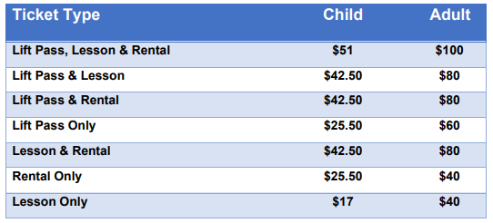
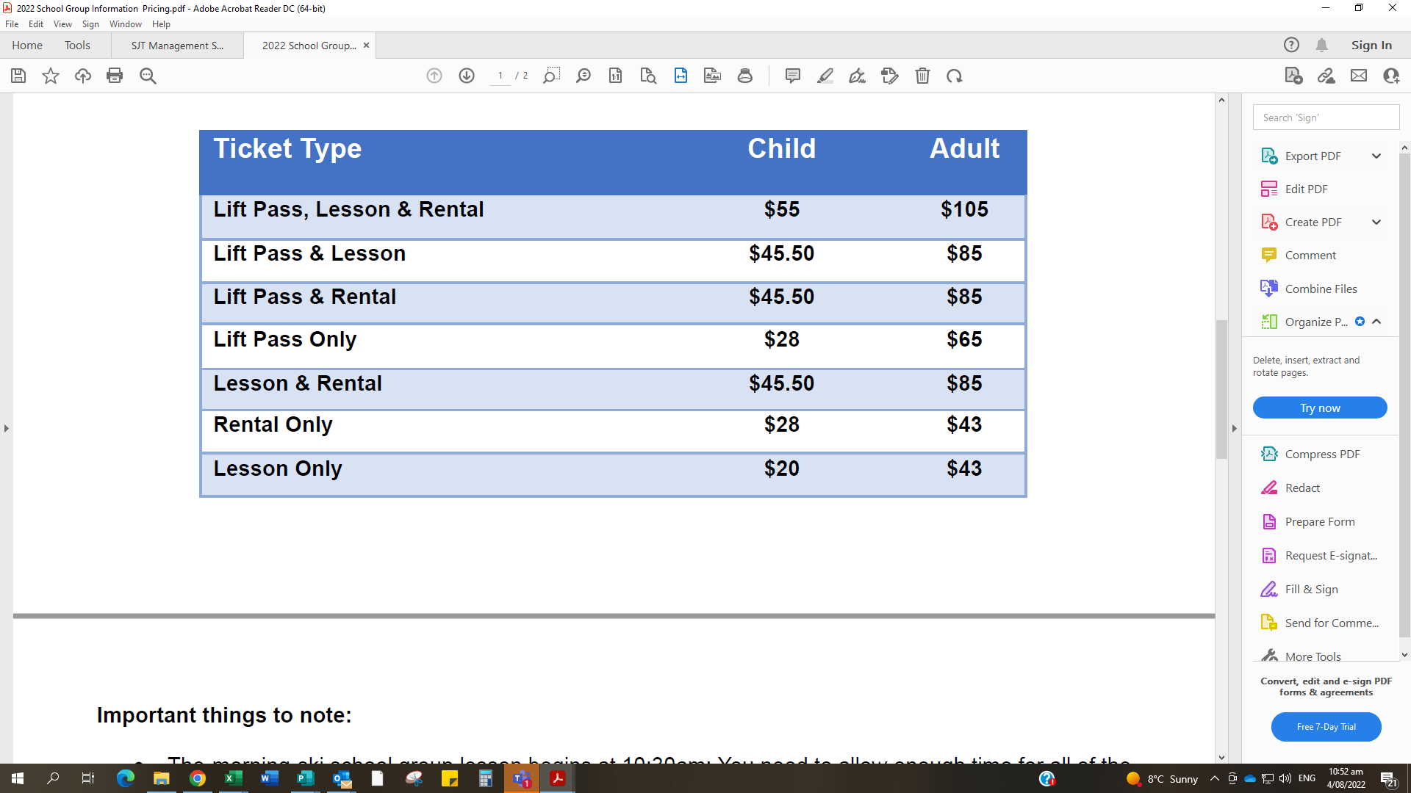
However, we do want to make sure that students still have this skiing opportunity at the school rate.

Therefore, students are invited to go skiing with their family at the reduced cost, as in the table.

We can assist by sending them the names of all skiers, being parents or students, prior to the day so we ask you to complete this form and return to school so we can confirm this date.

We will not be arranging a bus to the mountain, so parents will need to organise their own transport for students.

If the ski field is closed on this date, we cannot offer a cancellation date. If the mountain is closed students will be required to attend school.

_________________________________________________________________________________________________________
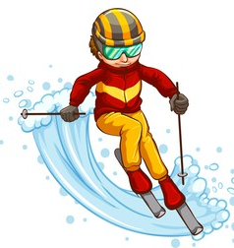
PLEASE RETURN THIS FORM TO THE SCHOOL OFFICE BY
FRIDAY 12th AUGUST (needed early by mountain staff to confirm booking)

Family Name _____________________________________________________________________

Number of students Skiing /Snowboarding ___________________

Names __________________________________________________________________________________________
_________________________________________________________________________________________________

_________________________________________________________________________________________________

Number of adults Skiing / Snowboarding ___________________

Names __________________________________________________________________________________________

_________________________________________________________________________________________________

_________________________________________________________________________________________________

Signature: ______________________________________________________

