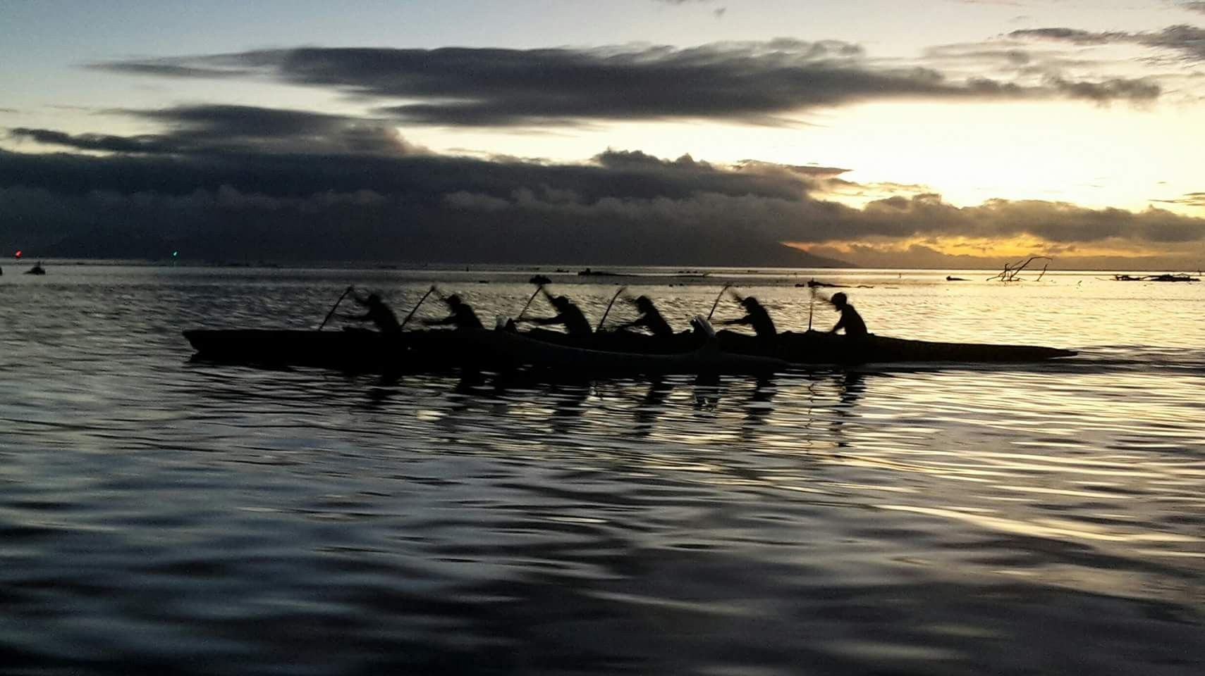  Date: 3 July (weather dependent)  Hoea te waka  Waka Ama Wānanga  A free Waka Ama wānanga series to have fun and build resilience through the tikanga of Waka.  5 one-day Waka Wānanga over a five-month period, where whānau can grow their strengths to navigate their own waka of dreams and potential. You will be notified of change of date if the weather packs up.  No paddle experience necessary, we will help with that.  For young people from the age of 14 years and whānau inclusive, all are welcome.  Contact to register and get more information:  Suzi 027 7460 337 or  Lisa 021 02715 186   | First, or closest to Sunday of the month (see back for more info)  ────  Held at Karitane, petrol vouchers to help with transport  ────  Get competitive & show your kaha  ────  Or be ngāwari & show your style  ────  Wouldn’t be an awesome kaupapa without Kai, so you won’t starve  

More information…

- Planned dates, but these are subject to change if weather cuts up
- Sunday 3rd July
- Sunday 7th August
- Sunday 11th September
- Sunday 2nd October
- Sunday 30th October

- You will need polyprop, fleece, quick dry or thermal clothing. No jeans, cotton hoodies or t-shirts on water.

- Paddles, booties and life jackets provided.

- Warm clothes to change back in to off the water.

- Water bottle if you have one, let’s keep hydrated.

- Whānau welcome.

- Any questions contact Suzi or Lisa.

