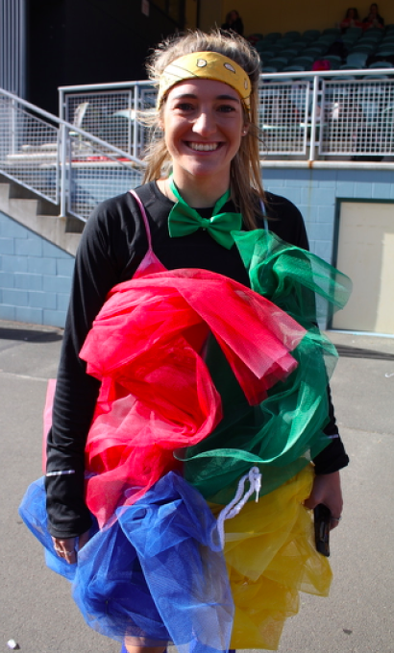
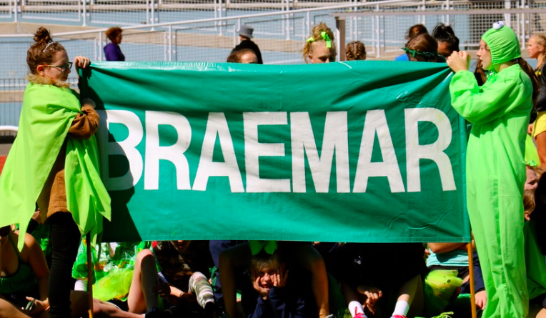
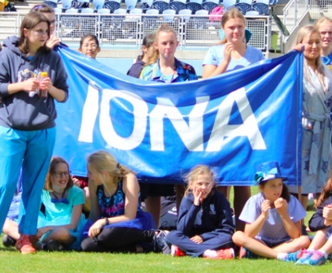
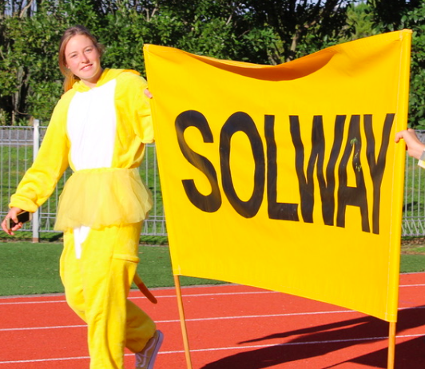
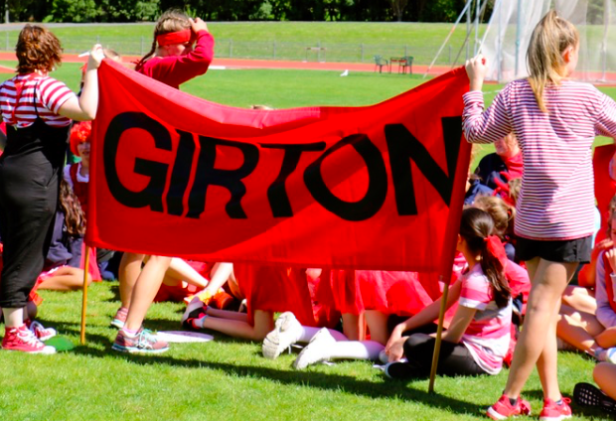

Columba College Athletics Sports Day
8.30am – 1.00pm
Monday 8 March, 2021
Postponement Day – Tuesday 9 March 2021
Caledonian Sports Track – Logan Park Drive

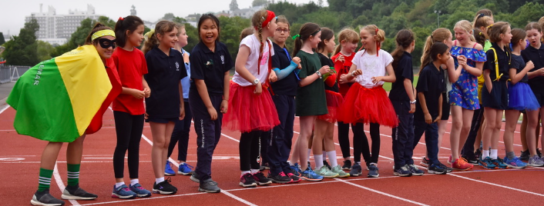
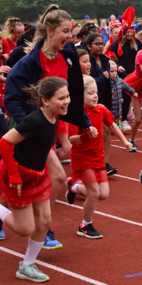
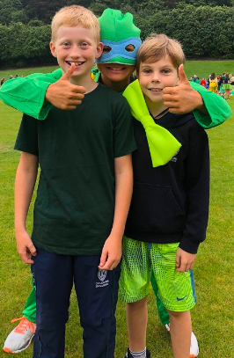
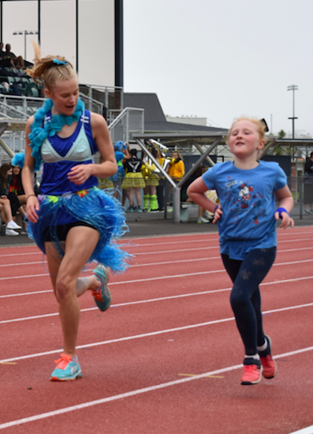
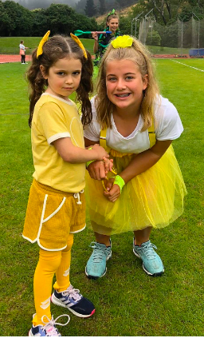
COLUMBA COLLEGE 2021 YEARS ZERO TO THIRTEEN ATHLETICS SPORTS

OFFICIALS
9.00am - 10.00am

MEETING MANAGERS, TRACK
and FIELD REFEREES Miss D. Turnbull and Mrs M. Hogg

CHIEF TIMEKEEPER Mrs B. Bridger

TIMEKEEPERS / PLACE TRACKERS Mrs M. Small, Mrs K. Cockcroft and Mrs V. Eason

MARSHALL Mrs J. Pollard

SPRINT TIMER Mrs G. Beardmore

MARSHALL Form Teachers

STARTER Miss D. Turnbull

RECORDERS Trackside: Mrs K. Lodge

9.00am - 10.30am
SPRINT RACES Back Straight of Track with Miss Turnbull

10.30 - 11.00am - MORNING TEA

11.00am - 11.50pm (Year 1 - 6) 10 min at each event then swap

HIT WICKETS Mrs J. Lach

SOCCER DRIBBLING Ms I. Ding

RUGBY PASS Mr J. Hayden

TURBOJAV Mrs S. Dixon

FRISBEE THROW Mrs R. Steel

12.00pm INTER-HOUSE FORM RELAY EVENT Full School - House Captains
1.00pm Depart Caledonian

HOSPITALITY (upstairs in the grandstand) Mrs J. MacLeod

FIRST AID First Aid Solutions

PHOTOGRAPHY Mr S. Shaw

ABSENCES, CLEAN UP and GATE SECURITY Mrs S. Graves

BBQ Prefects

PROGRAMME OF EVENTS

8.15 am Staff Report.
8.30 am Roll call by form teachers (in front of the grandstand).
8.40 am Students to assemble on track for a Full School House March Past.

Field Events  11.00 am:  1. Fun Events - Years 1 - 6 | Track Events  9.00 am: (Running down back straight)  1. Heats Primary 50m Age 5  2. Heats Primary 50m Age 6  3. Heats Primary 60m Age 7  4. Heats Primary 60m Age 8  5. Heats Primary 60m Age 9  6. Heats Primary 75m Age 10  7. Heats Primary 75m Age 11  8. Final Primary 50m Age 5  9. Final Primary 50m Age 6  10. Final Primary 60m Age 7  11. Final Primary 60m Age 8  12. Final Primary 60m Age 9  13. Final Primary 75m Age 10  14. Final Primary 75m Age 11  15. House Relays
10.30 - 11.00 am: Interval
12.00 pm: Inter-House Whole School Relays ALL Year 0-13
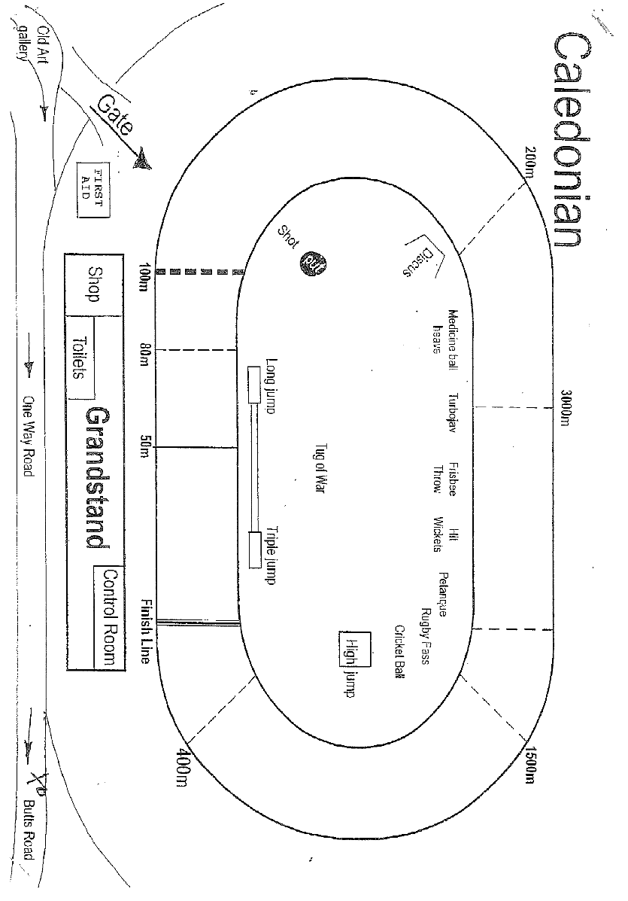
1.00 pm: Conclusion of Event - Depart Caledonian with Parents or Return to school for afternoon.

Columba College would like to warmly invite all families to take part in our annual Full School Athletics Day by coming down to the Caledonian Track to support our Athletes.

