 | Belfast School Newsletter  care I share I learn I grow
 | Thursday, 20 May 2021
Absences:  absences@belfast.school.nz  or text 027 6364254  Contact Details:  P: (03) 323 8849  E: office@belfast.school.nz  W: www.belfast.school.nz  700 Main North Road  Belfast  Christchurch 8051  Principal:  Sue Elley  Board of Trustees Chairperson:  Caroline Elkington  Dates of Interest:  Wed. 26 May – Y5-8 pupils at North Zone Cross Country – p.m. PP 02/06  Fri. 28 May – Winter Sports commence for Y5-8 pupils  LMS Cross Country – 2/06 at 1.15  JNR Cross Country – 2/06 at 2.10  Teacher Only Days: Thurs. 03/06 and Fri. 04/06 – School Closed  Queen’s Birthday – Mon. 08/06 – School Closed |     Welcome to our new Pupils:  Rocco Moriarty, Anousha Hassan, Oliver de Lambert, Monty Ranson,  and Toby Collins.  Dear Parents/Caregivers  Tēnā tātou i raro i te maru o Ngāi Tahu. Ngā mihi nui ki a koutou katoa. As-salamu alaykum. Hola. Talofa. Kon’nichiwa. Kamusta. Nĭ hău. Namastee. Magandang hapon.  Welcome to Term 2. This time last year we were returning from lock down and remote learning with restrictions on many of our sporting and planned trips. As we get organised for our senior winter programme this term, we realise that it has been two years since our students were able to participate in extra-curricula sport and compete with other schools. We know they are looking forward to this experience.  In the past week we have noticed the seasonal change with darker mornings, cooler temperatures and weather that can be very different throughout the day. From now on, we make plans for postponements for outside events in case the weather is not suitable. On Tuesday this week we were pleased that the afternoon turned out to be warm and fine so that our Year 5-8 cross-country event could take place as planned.  At this time of the year we have noticed that there is an increase in lost property, with children taking off layers as the day warms up. If clothing is named clearly, it is much easier to return items to the children.  One of the things we have learnt from COVID-19 is that we can greatly reduce the spread of winter colds and viruses by staying home when we are sick. This is something we want to continue so that as few people as possible are affected. Please keep children at home if they are unwell, particularly with any respiratory illnesses - colds, sore throats, coughs and asthma. If your child is unwell at school, we will ask you to collect them.  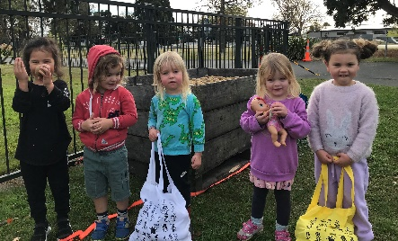  The donation of 700kg kiwifruit this week enabled us to share with our families, the Belfast Community Network, neighbouring pre-schools and others. We thought this was a great way to demonstrate our school value - SHARE. We were so pleased the fruit was able to be used rather than wasted.

 | Belfast School

Junior Building:
Work has continued with the construction team now heading towards completion near the end of June. The junior team has worked so well in their temporary places, however they are looking forward to returning to the building with the improved acoustics and lighting. We love seeing parents gathering by the gardens at the end of the day, and making use of the seats and tables. We encourage you to keep using this area once the juniors return to their building and arrange for them to meet you there.

Teacher Only Days - Thursday 3 and Friday 4 June:
On Thursday 3 and Friday 4 June, school will be closed for our staff to undertake professional learning. Our focus is on curriculum work with an emphasis on Reading. Teaching strategies are continually evolving and it is important for us to keep up to date. Teacher only days enable us to work in depth, develop new ways of teaching and plan changes to our learning programmes. Monday, 7 June is Queen’s Birthday holiday so children will return to school on Tuesday, 8 June.

Ako Meetings - for Parents/Caregivers, Students and Teachers:
These meetings will take place on Wednesday 23 June, 2:15-5:30pm and Thursday 24 June, 3:15-7:30pm. The Board of Trustees has approved school finishing at the earlier time of 2:00pm on Wednesday, 23 June to allow the meetings to begin at 2:15pm.

This is the opportunity for you, and your child, to meet with your child’s teacher to discuss their learning progress. We encourage you to attend these meetings to find out how your child is progressing, to have input to their next learning goals and what you can do at home. A notice explaining how to book a meeting time online will be sent home on Thursday, 10 June.

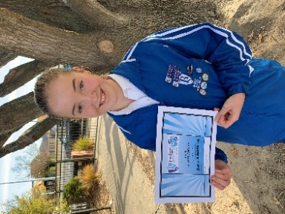
Blues Award:
This week Zara Johnstone R21 was presented with a Blues Award to acknowledge her success and achievements in Surf Lifesaving. Visit our article on our website https://belfast.school.nz/a/dHA4ceA so you can read more about Zara’s participation in Surf Lifesaving. Zara has won awards and medals at Canterbury and South Island Championships, as well as Club awards.

Year 7-8 Students:
A new article has been posted on our website about the focus for our Year 7-8 students. Follow this link https://belfast.school.nz/a/h7hcpOD to the article to read about how Years 7-8 at Belfast School prepare our young people for secondary school, and develop their leadership skills.

E mihi ana ki a koutou i tem ahi mīharo nei – thank you for all the great work you do in supporting your children at school. We appreciate being able to work in partnership with you.

Nga mihi nui

Sue Elley
Tumuaki - Principal

Belfast School


Neighbourhood Support Presentations:

Elissa from Neighbourhood Support attended our Assembly held on Monday, 17 May to present awards to Olivia Johnston R23 and Amani Macioce R21.

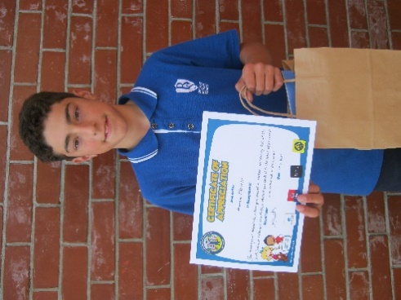
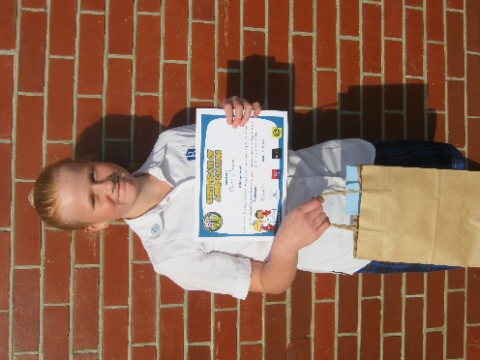
Olivia’s award was for her quick thinking when she noticed a car was unlikely to stop at the road crossing. She decided to jump ahead of a child who was about to step out onto the road to protect them.

Amani’s award was for being honest and helpful when he found a laptop accidently left at the park. Seeing that it belonged to a Belfast student, he took it straight to the school Office and it was returned to its owner.

Absences:
If your child is going to be absent from school, can you please let the school Office know by either leaving a message on the answerphone - 323 8849 option 1, send a text to 027 6364254, or by email to absences@belfast.school.nz Please state your child’s name, room number and reason why they will be absent. Thank you.

Children turning 5 years of age!
If you have a child turning 5 between now and December 2021 and who will be attending Belfast School, please enroll your child. We need to know how many 5 year olds are starting so we can plan for their visits etc. Please phone Sally on 323 8849 for further enrolment information or email principal@belfast.school.nz

Medical Issues/Health Concerns:
Please make sure you have discussed any medical issues with either the Principal when completing your child’s Enrolment form; or your child’s class teacher. If your child’s medical information needs to be updated, please collect a medical form from the school Office. This information is confidentially saved into our Student Management System so that we can provide your child with the necessary care.

School Lunches:
- Bakery items can be purchased for the children’s lunches on Friday mornings for Friday lunch. Full details and order forms are available from the school Office.
- You can also order online with Little Lunches for Thursday deliveries. Visit www.littlelunches.co.nz



Reminder that children are to wear winter school uniform in Terms 2 and 3. Belfast School’s school uniform items can be purchased at The Warehouse, Northwood.

Belfast School

Positive Behaviour for Learning (PB4L)

Congratulations to the following pupils who have earned their Certificate (Y1-4) and Certificate and Badge (Y5-8)

Room No. | Name | Certificate/Badge
7 | Zachary Boorer | Bronze Certificate
7 | James Rankin | Bronze Certificate
7 | Abby Kim | Bronze Certificate
7 | Kimberlee Kearns | Bronze Certificate
11 | Sophie Glynn | Bronze Certificate
11 | Charlie Paton | Bronze Certificate
12 | Jack Bonham | Bronze Certificate
12 | Cruiz Cameron | Bronze Certificate
12 | Azalea Collins | Bronze Certificate
12 | Tawhi Mataira-Kaiwai | Bronze Certificate
12 | Willow Rampling | Bronze Certificate
12 | Mia Stuart | Bronze Certificate
12 | Madi Manning | Bronze Certificate
14 | Taliyah Hyde | Bronze Certificate/Badge
14 | Hollie Lewis-Jensen | Bronze Certificate/Badge
14 | Alexander Maddock | Bronze Certificate/Badge
21 | James Rowe | Bronze Certificate/Badge
21 | Laisa Wadali | Bronze Certificate/Badge
23 | Tonga Strickland | Bronze Certificate/Badge

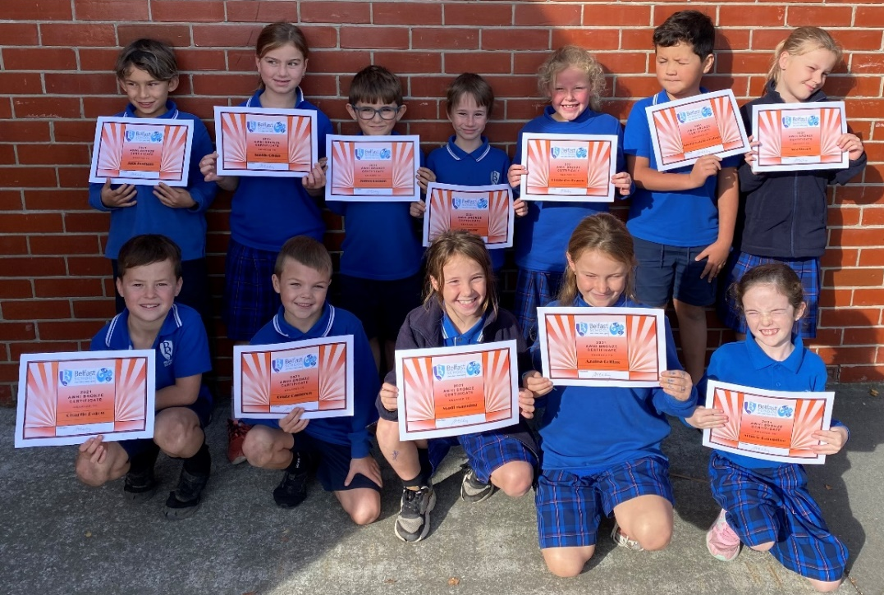



Community News

Fun Sticks Hockey Programme – Year 1 & 2 Children:
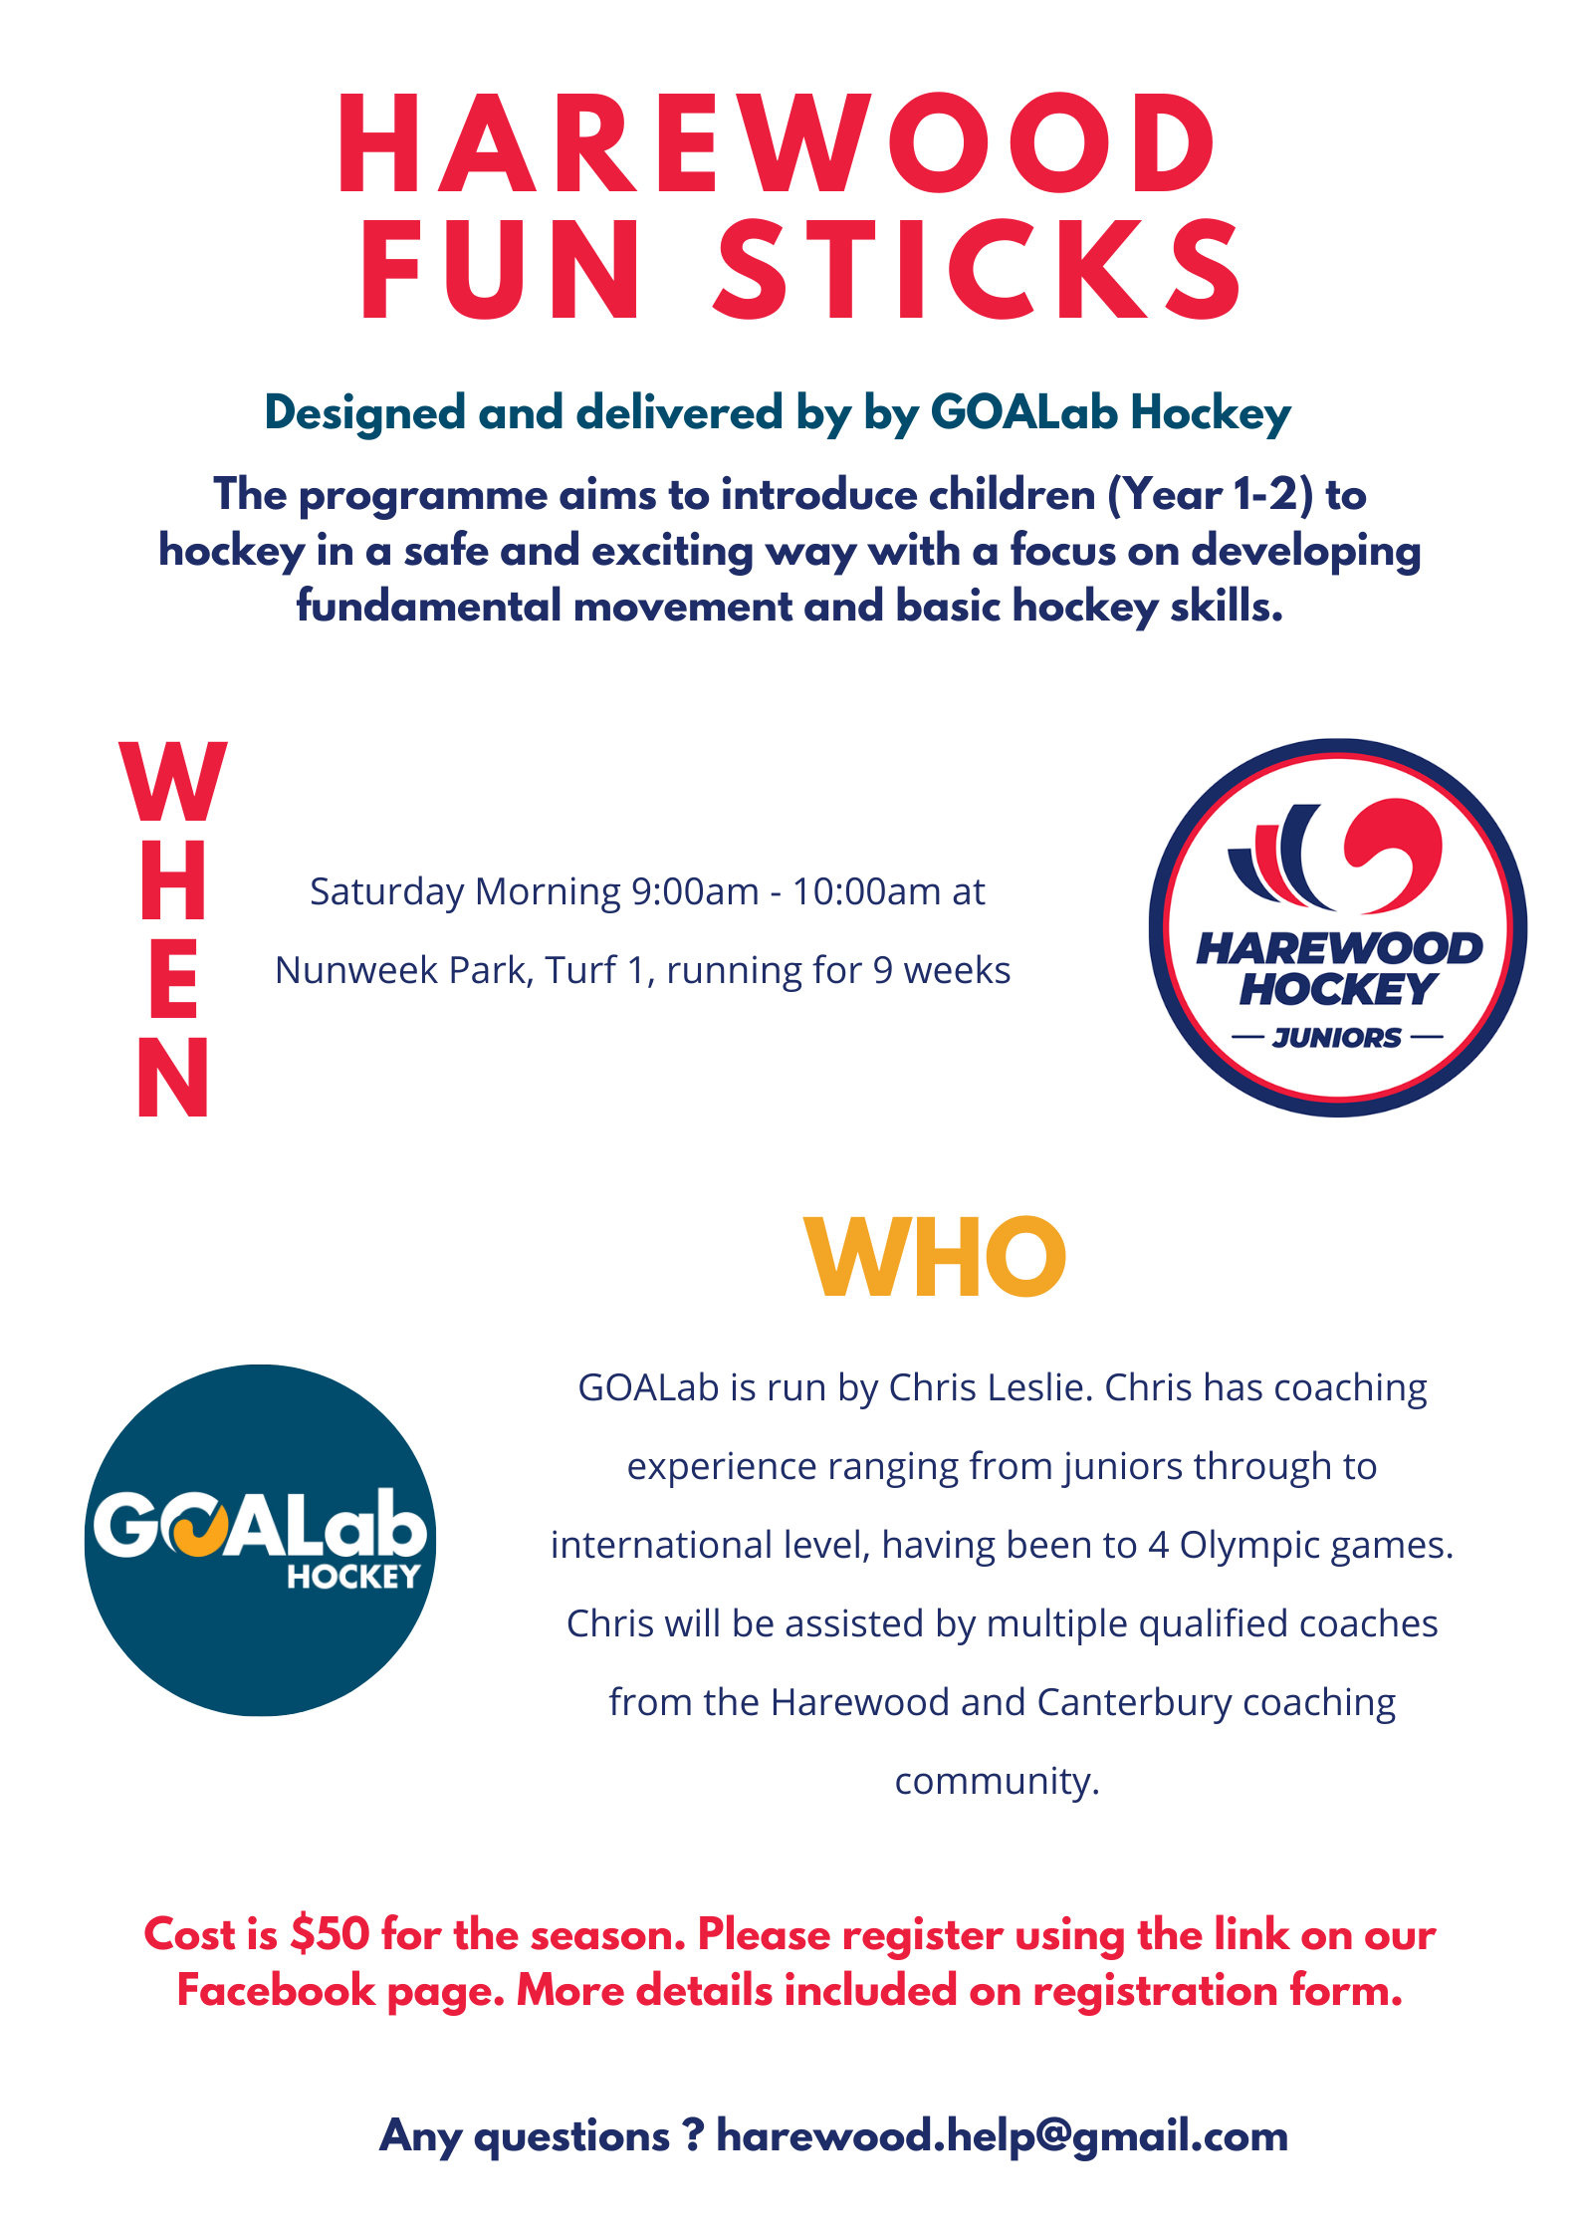

Community News

Christchurch Maths Craft Day:

Maths Craft are excited to announce the return of the Christchurch Maths Craft Day, on Sunday, May 23, in The Great Hall at The Arts Centre. Come along to The Great Hall and join us to discover the maths behind craft and the craft behind maths.
The day-long celebration of maths will feature a range of craft creation stations and public talks by mathematician crafters, and promises to engage people of all ages. Knit a mathematical knot, crochet a Möbius strip, fold an origami octahedron, and flex a hexahexaflexagon. Volunteers with backgrounds in mathematics and crafting will be on hand at all times to answer questions and assist people with their creations. Our guest speakers will present a series of maths and craft themed talks throughout the day, ranging in topics from fractals and pleating to crochet and chaos.
The Christchurch Maths Craft Day is free and open to everyone: experts and amateurs, maths-fans and maths-phobes, the crafty and the curious.

Date: Sunday May 23
Time: 10am-5pm
Location: The Great Hall at The Arts Centre, 2 Worcester Blvd, Christchurch
Cost: Free entry
Web: mathscraftnz.org
Social: #mathscraftnz, www.facebook.com/events/820943128516921/

Information Evening for Parents/Caregivers – Supporting Anxious Children:
Thursday, 10 June 2021 – 7.00-8.30 p.m.
This Free event at the Grace Vineyard Beach Campus, 111 Seaview Road, New Brighton is made possible thanks to the support of Youth Alive Trust and Grace Vineyard.
Link for tickets: https://events.humanitix.com/supporting-anxious-children
Being anxious from time to time is a very normal and healthy emotion but sometimes it can be difficult as Adults to know how best to respond to anxious children.
At this evening event Mana Ake staff will share about what is normal for young people at various ages and how as Adults we can support them. There will also be a short Q&A session after the presentation. So if you are a parent, grandparent, caregiver or work with young people this could be for you.
This evening is aimed at an Adult audience and unfortunately we cannot offer any child care or supervision during the event.
Mana Ake: Provides support to children in Canterbury, in years 1-8 at school, promoting wellbeing and positive mental health. For more information about Mana Ake and some helpful information aimed at parents and caregivers please visit our site https://manaake.health.nz/
Community News

Hagley College – Year 9 Enrolments for 2022:
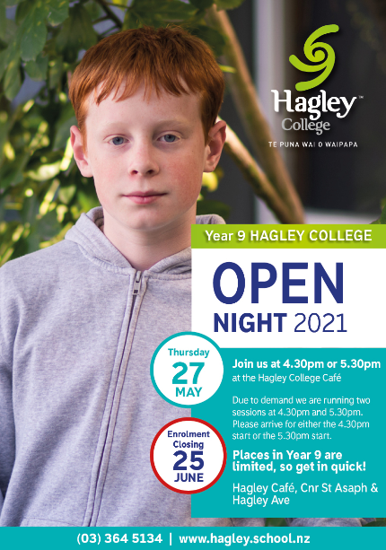

Woodend Playcentre – Hire for your birthday party!

Ideal all year round. Fully fenced, large outdoor area with archgola.
Use of indoor area and centre kitchen.

Hire fee: $110 ($60 + $50 refundable bond).

Contact: woodendplaycentrebookings@gmail.com

Community News


We are starting up a free programme for environmentally conscious kids.

Every Saturday, 10am - 3pm at the Kiosk in the Botanic Garden there will be fun activities for kids inspired by different organisations, including school holidays, in the Envirohub network. It's about connecting kids to our Environmental Community and having fun while we are at it.

This is an amazing opportunity for kids and for all the organisations involved.
Link to Envirohub Facebook Page
Sign up to the Envirohub newsletter

Annalee School of Dance:
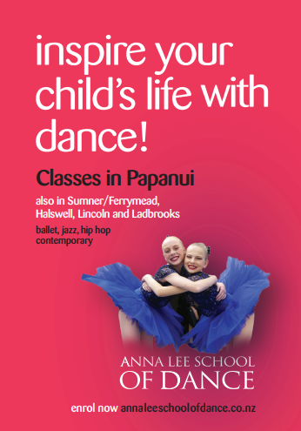

Community News

FREE Parenting Helpline:


