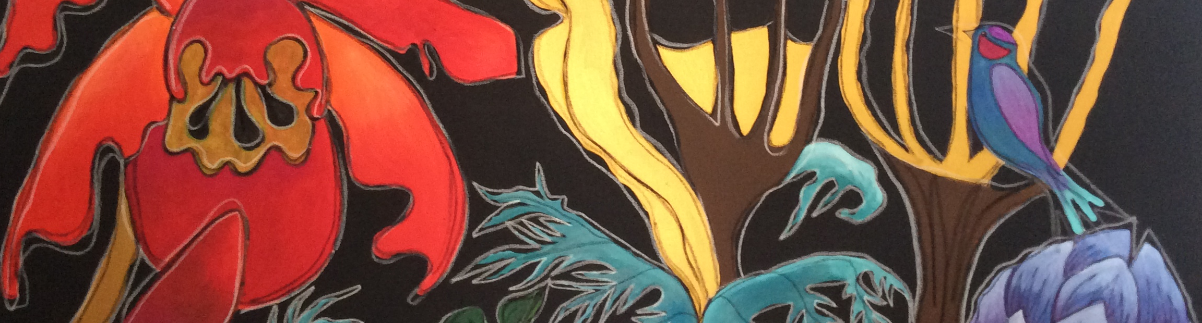

HOLIDAY WORKSHOPS
ART ALL DAY! 9am to 3pm $65+gst/day
NEW Mon’s & Tues at Westmere Sch
Thurs & Fri’s at The Homestead Pt Chev
TUES term1 ART T2 POTT T3 ART T4 POTT
THURS term1 TEXTILES T2 ART T3 POTT T4 ART
website www.holymoly.co.nz
All enquiries go thru Yolande and not the school, many thanks

Y O L A N D E L I G H T 0274 230 173
yoly@holymoly.co.nz
BEAUTIFUL ARTY BIRTHDAY PARTY
SEE WEBSITE FOR ALL INFORMATION
AFTER SCHOOL CLASSES 2023
3pm to 4.30pm Tues &/or Thursdays
Where – At School Te Are Bldg Cost $179+gst/term
Ages 5-11yrs Start in wk2, finish 2nd to last

