$52.00 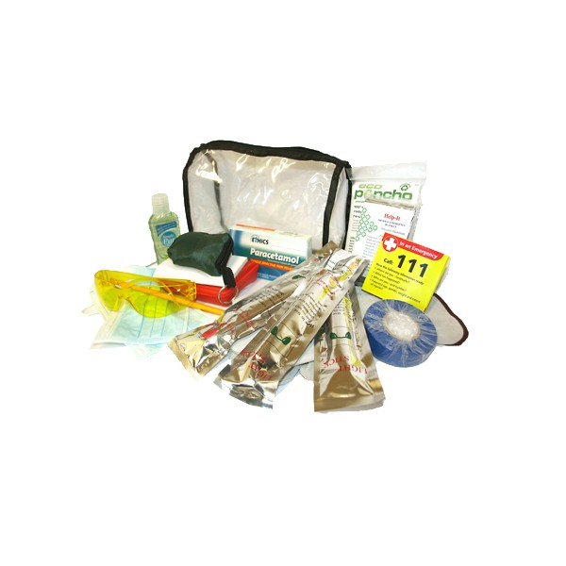

**Compact Glove Box Vehicle Kit**

Clear PVC Zip Up Bag

Pair Leather Work Gloves

Emergency Foil Blanket Small First Aid Kit

12hr Light Sticks Emergency Poncho

Dust Masks

Safety Glasses

Notebook & Pencil

Hand Sanitiser

CPR Mask

Keyring

Roll Insulation Tape

Paracetamol Tablets

First Aid Booklet