Theatre for Children Inc
Presents:
“Hansel and Gretel”
Written By and Songs By Amalia Calder
Starring: Clare Kerrison, Fergus Aitken, Hamish Boyle, Hannah Maison
Directed By Isobel Mackinnon
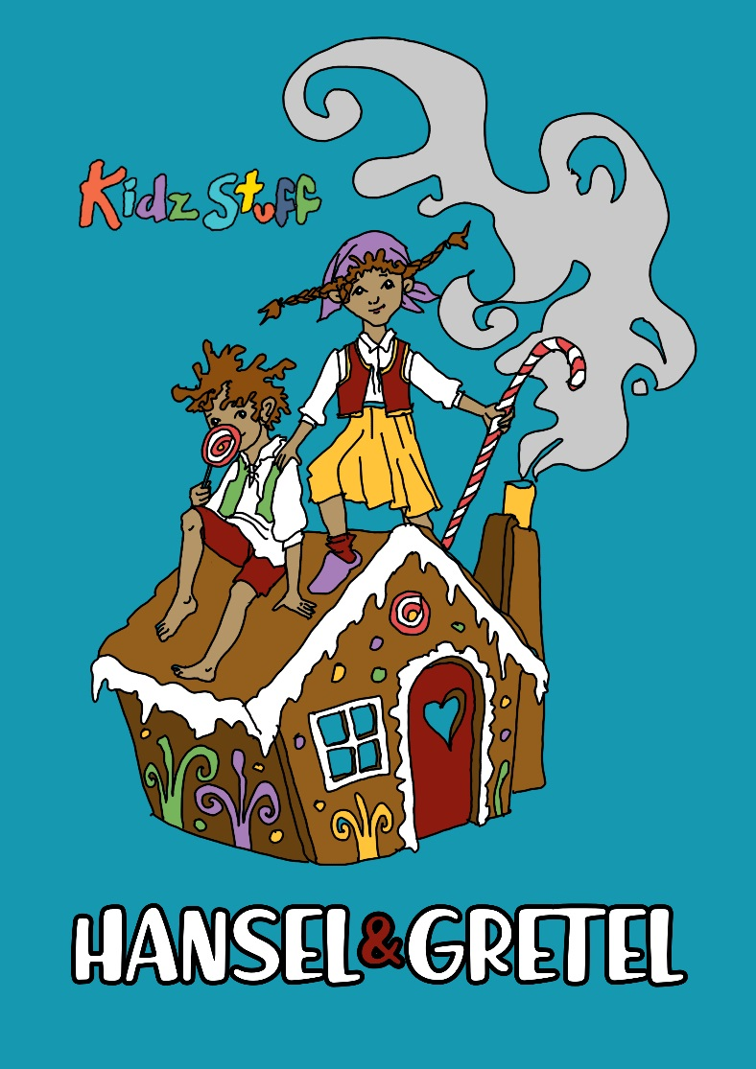
An energetic new Kiwi revival of the old Brothers Grimm classic, Hansel and Gretel.

Hans and G, as known in our version are up for an adventure of tremendous proportions. Facing an evil stepmother, an out of control pair of children’s elastics, magic sleeping powder and a very hungry witch!

Filled with lively, music and original songs. With physical comedy and a very colourful cast and set, Hans and G promises to be more fun than you can throw a stick at.

So, get out your breadcrumbs and make a path to the Tararua Tramping Club to help guide Hans and G to safety.

When: 6th– 19th July 2019.
Monday - Friday 10am & 11:30am
10am shows only on Saturdays!

Tickets $10.50 pp, Children under 2 Free
$7 Special Preview, Saturday 6th July 2019
Bookings: www.kidzstufftheatre.co.nz

Contact: Amalia Calder
027 271 7351 / kidzstuffnz@gmail.com
Media Release: For Immediate Release

