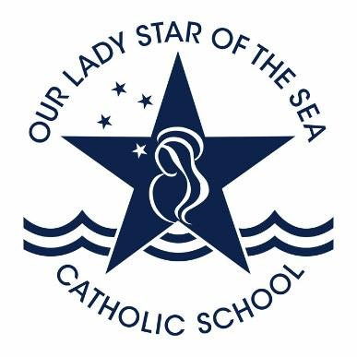
Our Lady Star of the Sea School

Participation Award in Swimming
Sports for 2023

This certificate is awarded to
Student name

Signed: Sophie Cull Date: 7th March 2023

