Brass Class 2020 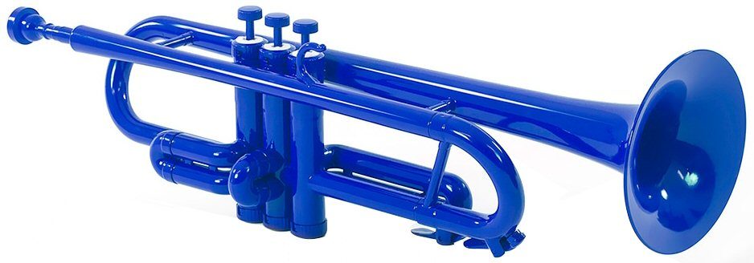

**Learn to play**

Allbrassclass offers your child (7 yrs or older) an accessible way to learn trumpet/trombone, as well as develop broad musicianship skills at school. It is taught by Dr Errol Moore, current tutor in Brass and Solomon Baldock, trumpet performance graduate at the University of Otago. The programme offers:

* a weekly 30 minute group (3-4 children)
* instrument hire of plastic trumpet or trombone
* music resources and texts provided free of charge
* ensemble involvement from Term 3 or 4

The family involvement is:

* Commitment to family supported home practice for 15-20 mins most days using routines and materials set in lessons
* commitment to learning to read music as part of the programme
* Likely involvement in the Allbrassclass ensemble programme from Term 3 or 4.
* Intention for children to continue to second year and beyond.

A plastic trumpet is the default starting instrument as most 7 or 8 year old children can readily manage the weight. If your child has a preference for trombone, this would require an individual lesson for a first-year child.

**Accessible Costs**

First Year lessons are $10.00 (3-4 children) with round 32 lessons over the four school terms. You may supply a suitable instrument or hire a P-Trumpet or P-Bone (Trombone) from Allbrassclass for a refundable damage bond of $30 paid in the first term, and $10 per term thereafter. Year 2 lessons are individual and $13 for 35 minutes.

For further information, please email or phone Errol or talk to music teacher at your school.

**Why Brass**

*As adults, brass playing is a versatile hobby, community recreation or profession. Almost all musical groups make use of skilled players ranging across tuba, trombone, horn, euphonium and trumpet/cornet. While you might start on trumpet, it takes a year or two to establish which instrument might suit best. Like most musical involvements, the brass community is huge and international. You will have music making friends for life and all of the engagement with music you could possibly hope for.*

Errol is 0272896570 [allbrassclass@gmail.com](mailto:allbrassclass@gmail.com)

**Allbrassclass Student Enrolment Form**

**(A fully completed and legible return is essential for every child wishing to learn) Please return to the music teacher at your child’s school or email scan to** [**allbrassclass@gmail.com**](mailto:allbrassclass@gmail.com) **)**

Child’s School: Full Name of Child:

Age: Tick Instrument choice: Trumpet/Trombone

Home Address:

Best Contact Email (For billing and updates):

Main contact name: Cell phone: Hm Phone:

Alternative contact name: Cell phone: Hm Phone:

Please **tick** ✔️each bullet to show your support:

* My child and I have listened to several examples of brass and trumpet playing in making a decision for her/him to learn (YouTube has many examples… Enjoy ☺).
* I agree to my child learning trumpet in the Allbrassclass programme. In agreeing, I have discussed recreation time implications with my child and understand commitment is important for my child to be able to continue in this school time programme.
* I will be supportive of my child’s involvement, monitor application of lesson practice notes, be actively involved in practice at home at least once a week and communicate as needed with the tutor.
* I will support my child in ensemble participation from Term 3 or 4 (Monday late afternoon George St School).
* I will supervise care of the instrument and cleaning once per term
* I understand, that the maximum group size for Year 1 classes is 4, hence, my child may not be able to be included.

Name of parent……………………….

Signature: Date: