

**Keep up to date with our school news and notify of your child’s absence via our Skool Loop app!**

*A free download from your App store or Google Play.*

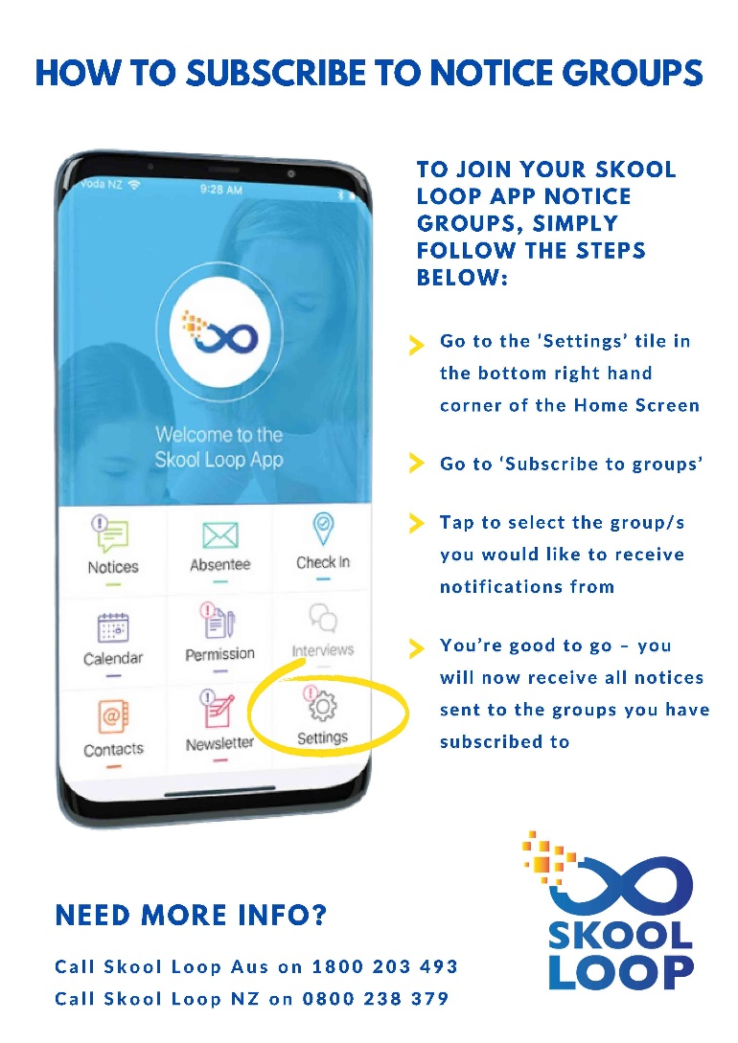

[](https://apps.apple.com/nz/app/skool-loop/id1043396607)

](https://play.google.com/store/apps/details?id=au.com.parentteachercalendar&hl=en_NZ&gl=US)