
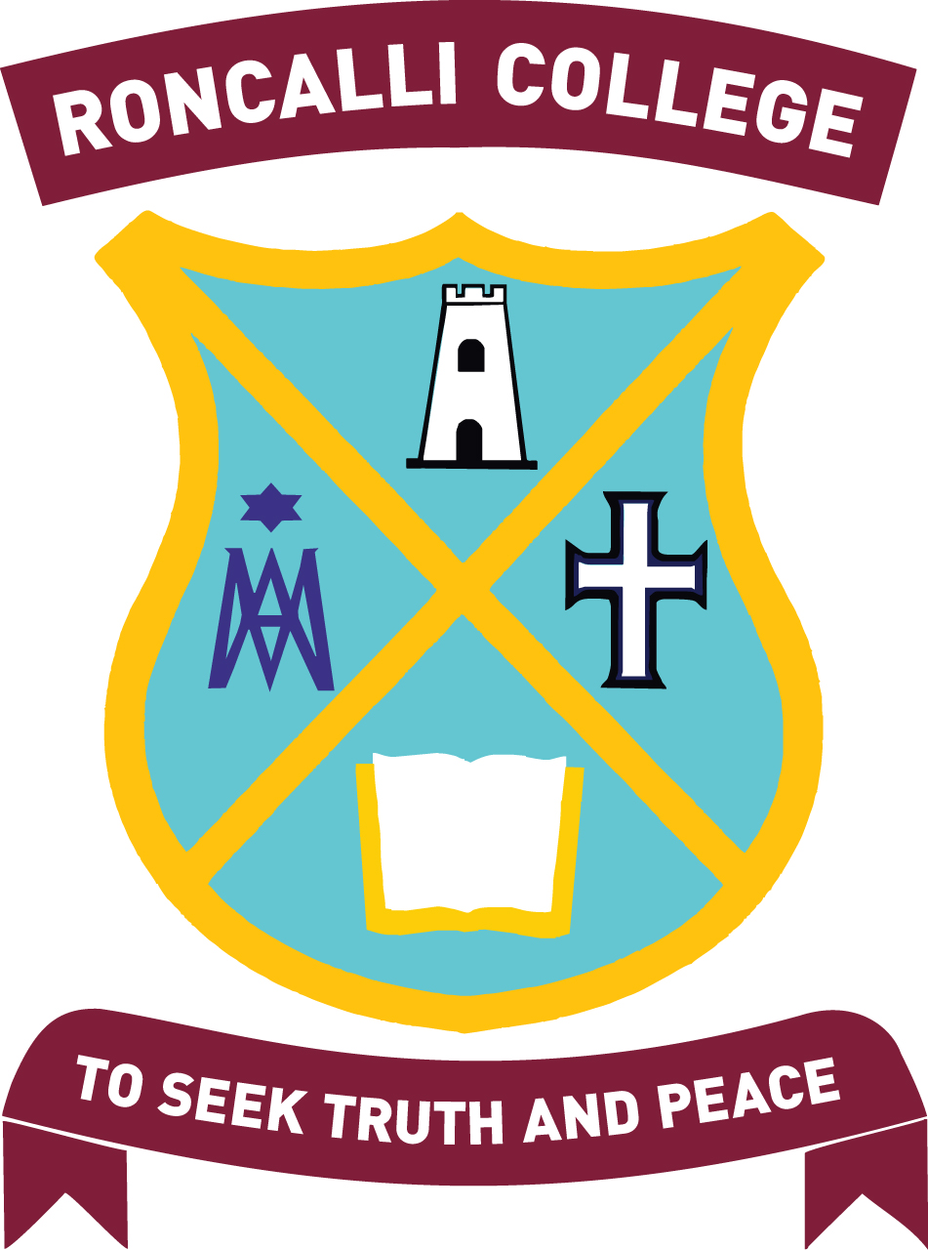
Christmas Truffles
1 dozen $5.50 or 3 dozen for $15.00

The Awa Run is a 4-day cultural experience where a group of 65 year 10 students from the
Marist Network Schools run along the scenic Whanganui River to raise funds to support
disadvantaged communities where our Young Marist Programmes are based.

Roncalli are sending seven students, we will each run 20kms per day.
We are seeking sponsorship for this run and also selling Christmas truffles
to contribute to both the fundraising venture and to assist with the costs of the trip.
We appreciate your support!
Name | Contact | Quantity | Total

