Sausage Sizzle Fundraiser – July 3rd

We’ve set up our Kindo online school shop to make it easy for our families to support school fundraisers anywhere, anytime. It’s open 24/7 and available at www.mykindo.co.nz .

We’re holding our first sausage sizzle fundraiser on July 3rd and we’re taking orders online now! If you already have a Kindo account, you can log in and place your order using your existing details, if you are new to Kindo, follow the steps below to create an account;

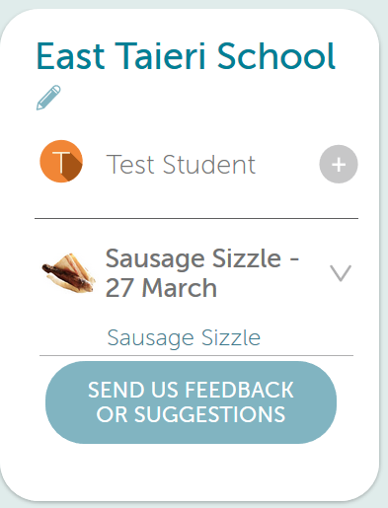
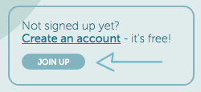
1. Click here for our Kindo online school shop login page.

2. Select the ‘Join Up’ icon.

3. Enter in your email address, name and contact number, and your password.

4. Enter in your child/ren’s names.

5. Tick the box to agree to the ‘terms of trade’.

6. Select Register.

Your family account is now set up. Next time you log in, you will just need to enter your email address and password.

We also have a YouTube tutorial to show you how to use the shop:

Click here to see how our Kindo online school shop works

SAVE TIME – PAY ONLINE

