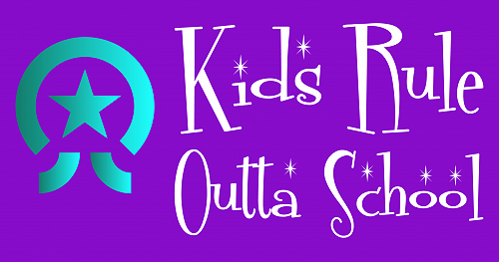

Teacher Only Day
Friday 7th February 2020
Do you need somewhere for your child to be while the Teachers have a day of learning?
Book in now with the team at KROS
Available 8.30am to 6.00pm at Saint Paul’s
$50 for the day - spaces limited so be quick
We offer an after-school program based at Saint Paul's for Saint Paul's students. Monday - Friday from 3pm - 6pm during term time only.
No need to drop off, only pick up. Afternoon tea is provided daily.
Bookings are being taken now for next year – 2020
For enquiries please contact Maree Jenkinson:
Phone 022 436 1139
email: office@kidsruleouttaschool.co.nz or
login to: https://kidsruleouttaschool.aimyplus.com to register

