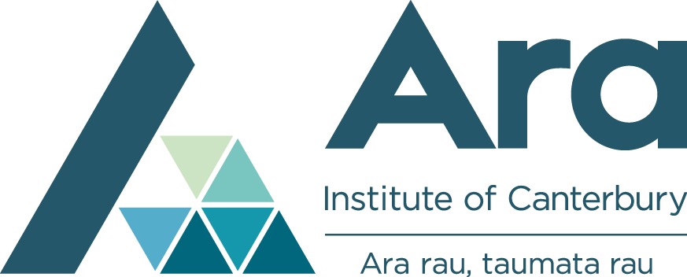

Free computing courses, flexible start dates
We offer a range of computing courses at our Ara Connect community centres across Christchurch, Rangiora and South Canterbury. At Ara Connect you can learn the basics of using computers, digital devices and common programmes, or gain a formal computing qualification for employment and further study in IT.
Courses and class times are flexible, allowing you to fit your study around work, family and other commitments. You can start any time and study at your own pace and best of all most Ara Connect courses are free.
Our free computing courses at Ara Connect give you skills and knowledge to broaden your employment opportunities, or advance with confidence to a formal qualification such as the New Zealand Certificate in Computing Level 3 or Level 4 (see below for details).
Explore our range of free community computing courses here
https://www.ara.ac.nz/study-options/short-courses

How to apply
To apply for one of our short courses, fill in a paper copy of our application form, available here, then either drop it in to your nearest campus.
Pop in to your local Bishopdale Ara Connect Centre today and have a friendly chat with Bhaswati or feel free to ring her at 359 3278.

