18th February 2016

Dear Parents and Caregivers

It was great to see so many parents at our meet the teacher evening earlier this term. We would now like to make an opportunity for you to have a brief 10min interview with your child’s teacher. This will be an opportunity for you to discuss how your child has settled into school and to share information. It is also a chance to discuss learning goals that may be of use to your child.

We are using an online booking system for our interviews. Some of you may be familiar with this system. You will need to go to [www.schoolinterviews.co.nz](http://www.schoolinterviews.co.nz) and enter our school’s unique code **r28zz**

From here you need to select your child’s teacher and then select a time that suits you for an interview. You will then be sent a confirmation email.

Please note, Room 10 are unavailable on this booking site. They have had to hold their interviews earlier due to their school camp being in week 5.

If for some reason you are unavailable for all of the allocated interview times, please contact your child’s teacher to arrange another time that suits.

Bookings for parent interviews will **open at 9am on Friday 19th February and** **close at 8pm on Sunday 28th February**

*This message has also been sent to parent emails. Email is our preferred method of contact with parents, because it is instant and paperless. If for some reason you are not receiving school emails, we would appreciate if you could* ***email “please add my email” to squelch@balmacewen.school.nz*** *so that we can update our school email list.*

Thank you for your support and cooperation

Yours sincerely

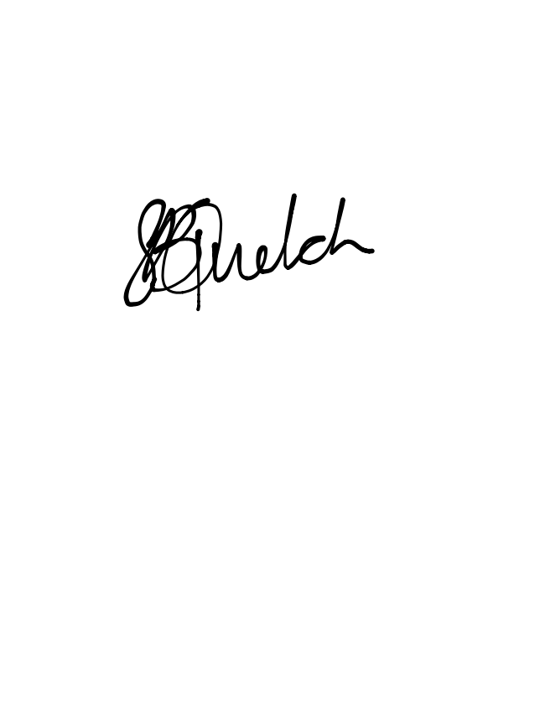

# Sara Quelch

**DEPUTY PRINCIPAL**