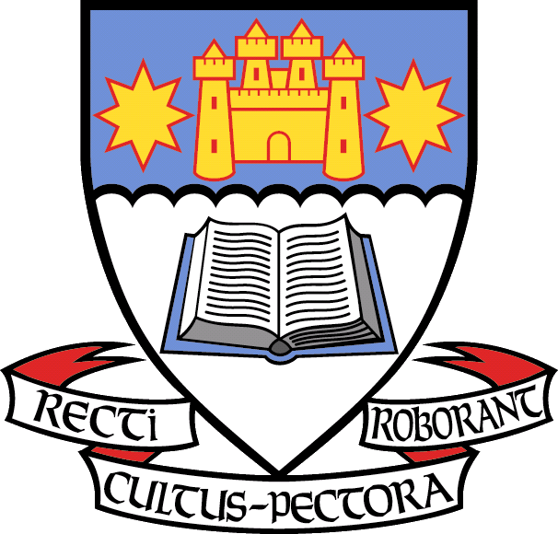
- Please fill in your order details below.
- Proceeds from the sale of the first aid kits go towards the OBHS Parents Association fundraising efforts.
- Please see information sheet for more details about the first aid kit.
- Thank you for your support!
Fundraiser: | Otago Boys’ High School
Fundraising Group: | OBHS PTA Association
Co-ordinators | Emma Dickson 027 303 8613 Sharron Dunbar 027 330 8585

Name | Qty | Total Price  ($39.95 each) | Payment Details
Total

Payment by cheque, cash or eftpos can be made at the school office. Please make cheques payable to OBHS Parents Association. Alternatively, you can deposit your payment into the following account: ANZ 06 0901 0026179 00 (OBHS Parents Assn). Please use First Aid Kit as your payment reference.

For further information please contact:
Emma Dickson 027 303 8613 – dickson.fam@xtra.co.nz
Sharron Dunbar 027 330 8585 – dunbar.clan@xtra.co.nz

First Aid Kit Order Form

