Tai Tapu Keas and Cubs groups
Come along for adventure at Keas and Cubs in Tai Tapu.
Keas is the youngest section of SCOUTS New Zealand and is for girls and boys who are aged between 5 and 8 years. Cubs is for boys and girls aged 8 to 11 years.
Currently both groups meet at the Tai Tapu Scout Den, State Highway 75, Tai Tapu on Tuesdays from 3.30pm to 4.30pm.
By coming along to Keas or Cubs you will have lots of fun, make new friends, and learn some new skills. We look forward to meeting with you and showing you what great fun being a Kea or Cub can be. Yours in Scouting.
For more information contact Victoria at 021895385
Keas - 5-8 Years
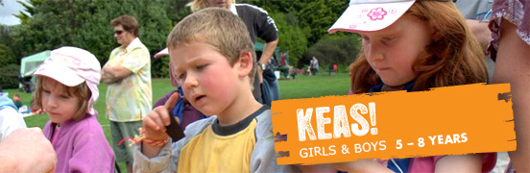
Kea Clubs provide safe and nurturing environments for children to have fun and develop their creativity...
As a Kea you will interact with nature and learn to share through co-operation and teamwork. Keas meet weekly at local Scout Halls and engage in both active and quiet games, stories, creative crafts, play-acting and singing.
The Kea motto is: 'I Share, I Care, I Discover, I Grow.'
As a Kea you will:
- have lots of fun and go on awesome adventures
- play heaps of games and make lots of friends
- earn Award badges
- learn the Kea Promise and Motto
- learn to sing the Kea Song and Kea Yell
- take part in National Events such as Keas Day, Founders Day and Mudslide Day


Cubs - 8-11 Years
Cub Packs offer learning programmes where children are encouraged to experience, experiment, and explore...
The Cub section is for children aged 8 to 11 years. They meet weekly at their Scout Hall and take part in all sorts of cool activities.
As a Cub you will:
- have lots of fun taking part in awesome activities like outdoor adventures, camping, bushwalking, outdoor cooking, expeditions, helping your Community, play games and making lots of friends.
- have the chance to earn Personal Challenge Badges like Swimming, Hobbies, Pet Keeper, Scientist and Fishing, and each year of Cubs you can work towards the Bronze, Silver and Gold Awards.
- be able to work towards the premier Outdoor Adventure Award.

