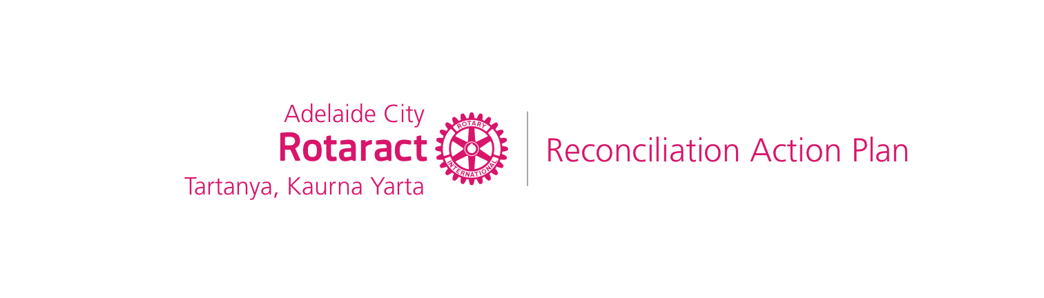
Reconciliation Action Plans
Information for Rotary and Rotaract Clubs

What is a RAP?

A Reconciliation Action Plan (RAP) is a strategic document that includes practical actions that will drive an organisation’s contribution to reconciliation both internally and in the communities in which it operates.

The RAP Program, facilitated by Reconciliation Australia, contributes to advancing reconciliation by supporting organisations to develop respectful relationships and create meaningful opportunities with Aboriginal and Torres Strait Islander peoples.

RAP types

There are 4 types of RAPs that an organisation can develop; Reflect, Innovate, Stretch, and Elevate. All organisations begin with either a Reflect or Innovate RAP and as a volunteer organisation, the Reflect RAP is the most appropriate and achievable to begin with. The other RAP types require organisations to implement strategies which may be more difficult to tailor for Rotary Clubs but could still be explored after implementing your first Reflect RAP.

Why is it important for Rotary and Rotaract Clubs to have a RAP?

RAPs make a difference across Australia in workplaces, universities, schools, governments, and community organisations – just like Rotary.

As community service leaders, we have a role to play in contributing to reconciliation and ensuring our service projects, initiatives and membership opportunities are inclusive of Aboriginal and Torres Straight Islander peoples. The RAP framework enables us to do this by:

- building and encouraging relationships between Aboriginal and Torres Strait Islander peoples, communities, organisations, and the broader Australian community
- fostering and embedding respect for the world’s longest surviving cultures and communities
- developing opportunities through Rotary to improve socio-economic outcomes for Aboriginal and Torres Strait Islander peoples and communities

By developing a RAP, your club can:

- implement a tried and tested framework, that is proven to drive reconciliation through practical actions
- reaffirm Rotary’s integrity by embedding an engaging framework contributing towards good governance practices used by organisations across Australia
- join a dynamic, supportive and fast growing network of RAP organisations
- gain greater esteem as a volunteer organisation of choice and build a more dynamic and diverse membership group
- enable your members to develop greater cultural awareness and professional development practices that will strengthen relationships with Aboriginal and Torres Strait Islander stakeholders

How does a club start the process?

Reach out for support

Adelaide City Rotaract Club (ACRC) are the first club to have a developed a RAP but we hope we won’t be the last! You can view the ACRC Reflect RAP on our website and use it as a guide in the development of your own RAP. We would love to make the inclusion of Aboriginal and Torres Strait Islander peoples the norm in Rotary and look forward to supporting our Rotary network to achieve this. You could also investigate whether your workplace or other reputable organisations have a RAP, including government and non-government organisations, businesses, schools and your favourite sporting team.

Express an interest with Reconciliation Australia

Submit an Expression of Interest form on the Reconciliation Australia website. You will then be emailed further information about the RAP program. Although the information provided indicates that a volunteer/community organisation is not well suited to the RAP framework, our conversations with Reconciliation Australia have confirmed that the actions and deliverables can be tailored to the structure of Rotary clubs, particularly in a ‘Reflect RAP’. The ACRC Reflect RAP is proof! For instance, deliverables which relate to employees can easily be tailored towards club membership. If you still aren’t sure though, contact the Reconciliation Australia team to discuss further.

Talk to your Club Board

Raise the initiative to develop a RAP with your Club Board and provide as much detail as necessary for them to make an informed decision about whether to proceed. Use the support and information offered above as necessary.

Register with Reconciliation Australia

If your club is ready to begin drafting your RAP, register with Reconciliation Australia.​ You will then receive the templates and resources required to enable you to begin drafting your RAP.​

Identify RAP Working Group members

The RAP Working Group (RWG) is considered the governing body of the RAP. The RWG is ultimately responsible for the development, implementation and reporting phases of a RAP. It is therefore important to establish an effective RWG in order to develop a RAP. We recommend this include at least one board member to liaise between the Club Board and RWG. The number of members on your RWG will depend on the size of your club but all RWG members should be committed to promoting reconciliation.

You might find it useful to consolidate RWG membership, roles, responsibilities, meeting details, agendas and reporting requirements in a set of guidelines such as a Terms of Reference (TOR) document.

Develop your RAP

While Reconciliation Australia will provide you with a template to develop your RAP, it is a good idea to add your own actions and deliverables which are relevant to your club. Perhaps there is a relevant project you would like to include? The best way to determine what these actions might be is through consultation with your club members and with Aboriginal and Torres Strait Islander stakeholder organisations. This may involve surveys, focus groups, or individual consults.

Around this same time, you should start thinking about the RAP artwork to be featured on the final version of your RAP. Your RAP artwork should be created specifically for your Club’s RAP and commissioned by an Aboriginal and/or Torres Strait Islander artist. Talk to them about your club demographics, values, vision, and purpose to give the artist some insight into what meaning they should add to your artwork. Draw on your personal and professional networks to help you identify an artist willing to create this art for you.
​
Submit your draft RAP to Reconciliation Australia

Once you have drafted your RAP, submit your word document to Reconciliation Australia through the Submission form to start the review and development process. After receiving feedback from your RAP officer, you can arrange a time with them to discuss your RAP.​

The feedback provided from Reconciliation Australia is detailed and comprehensive and should be addressed with attention to detail. Your draft may go back and forth between your club and Reconciliation Australia a number of times and this is all part of the process.

Once you have addressed all the feedback provided, Reconciliation Australia will provide you with conditional endorsement, pending the review of your final document, complete with Club logos and Reconciliation Australia graphics (which they will provide you). Only once Reconciliation Australia has confirmed that their graphics conform to branding guidelines will they provide you with final endorsement.

Launch your RAP

Receiving endorsement of your RAP from Reconciliation Australia is a huge achievement and the result of a significant amount of work and consultation and should be celebrated! Hosting a launch event also provides the perfect opportunity to communicate in more detail about your RAP to all club members and supporters which is an important part of the process.

It’s also a milestone which marks the beginning of the implementation phase of your RAP actions and deliverables.

Is a RAP a political document?

RAPs focus on inclusivity which is not political. Reconciliation Australia’s required deliverables, outlined in their templates, are non-political. If an organisation wants to add a deliverable which is political, such as wanting to actively support/promote the ‘change the date’ campaign, Reconciliation Australia would support them in coming up with that deliverable, but it's not a requirement in the template and Rotary Clubs would not be expected or required to add any deliverables like that.

Primarily, the actions and deliverables of a RAP initiate increased education for members and inclusive protocols which ultimately will make our clubs more accessible to and inclusive of Aboriginal and Torres Strait Islander peoples.

Put simply, a RAP provides us with the knowledge and resources to be more inclusive clubs. This is a goal of Rotary International who have stated that:

Diversity, equity, and inclusion is not a political issue; we all have the right to be treated with dignity and respect, to have equal opportunities for fellowship and service, and to be given the same platforms for our voices to be heard.

You can read more about Rotary’s commitment to Diversity, Equity and Inclusion, on the My Rotary Website.

Where can I find more information and resources?

https://www.reconciliation.org.au/

