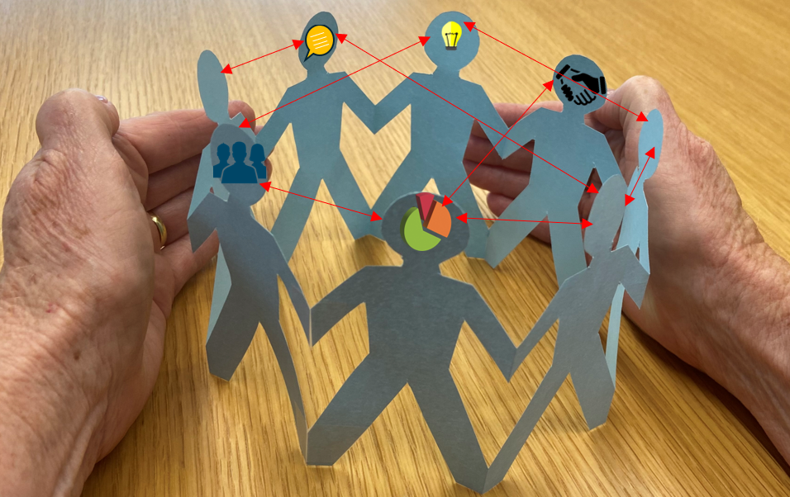
Knowledge sharing
At the Connexional Office we have been doing some thinking about values, what are values within the office and how they relate to the values of Te Hāhi Weteriana o Aotearoa.
Love . Aroha . Manaakitanga . Tapu Kaitiakitanga . ‘Ofa . Alofa . Fa’aloalo . Loloma Matangi Kolo . Responsibility . Responsiveness Hospitality . Reciprocity . Generosity
This has made me reflect (re-reflect?) is my work reflecting the values and Mission Statement of Te Hāhi?
Currently I am looking at creating a knowledge sharing programme for the Connexion. What I have in mind is offering the Connexion a body of knowledge, primarily related to health and safety, and property compliance that will assist when and where it is needed.
In my mind, this comes from my responsibility as an employee of Te Hāhi, and a responsiveness to gaps I have noticed within the activities of our Hāhi. However, it will mainly support the Connexion to enact manaakitanga, kaitiakitanga and responsibility.
I have also considered people’s generosity with their time and what to ensure that efficient use of that time is maximised.
So here is the concept from my perspective.
A series of knowledge blocks offered to the property and leadership teams across the Connexion, starting with health and safety, compliance and risk. This will be done with a view to:
- Minimise the time requirement for participants
    - Each block will aim to be half an hour long plus discussion time.
    - Participation is strongly encouraged and never mandatory
    - Encourage group participation, for example, include a knowledge block into a regular meeting (share the knowledge within the group) and also allow individual participation
    - Participants can select the most convenient time, place and means for them
- Maximise relevancy to participants
    - Participants will be able to evaluate the topic's relevance prior to signing up
    - Participants pick and choose as many or as few blocks of relevant interest or need
- Maximise the autonomy and rangatiratanga of all Church entities by offering the wanted knowledge at the wanted time
- Maximise Church entities’ compliance with Church and secular law
To be able to offer half-hour sessions does mean that the topics will be quite targeted rather than generalised. For example, ‘Asbestos’ will not be an option. The options will be based around ‘what are you doing with the asbestos?’
- Asbestos – information for decision making (demolish, refurb, or put it on hold)
- Asbestos – ongoing management of known asbestos (until permanent removal)
- Asbestos – construction projects (what to expect with asbestos removal work)
- Asbestos – property portfolio management (what and where asbestos is in the buildings)
A targetted approach does mean that the list of knowledge blocks will be extensive, however I think the benefit will be greater for each property or leadership team as they will be able to mix and match what is offered to suit their timeframe and knowledge needs.
I also think that it is important to ensure that there is reciprocity of knowledge. I need to have conversations within the Connexion to understand what compliance means outside of my own headspace.
- This knowledge sharing targets the “how to” and not necessarily the “why”. Is this what’s needed?
- Do the differences between Church requirements and legal requirements (such as NBS, parsonage v residential tenancy) need to be highlighted?
- Are parishes and other church entities able and prepared to do compliance work?
- What are the barriers to achieving compliance for parishes and other church entities?
I guess if I was going to shrink all of the above into a nice short paragraph... I would like to offer the Connexion relevant knowledge when it is needed so that their task of managing health and safety and building compliance is easier and on-point.
But I still have to find out what that means to the Connexion and what would help most. So please watch this space, we need to talk!

Manaakitia ō tātau tāngata. Care for our people.

Ngā mihi aroha ki a koutou katoa. Keep Safe.
Nā Trudy Downes

