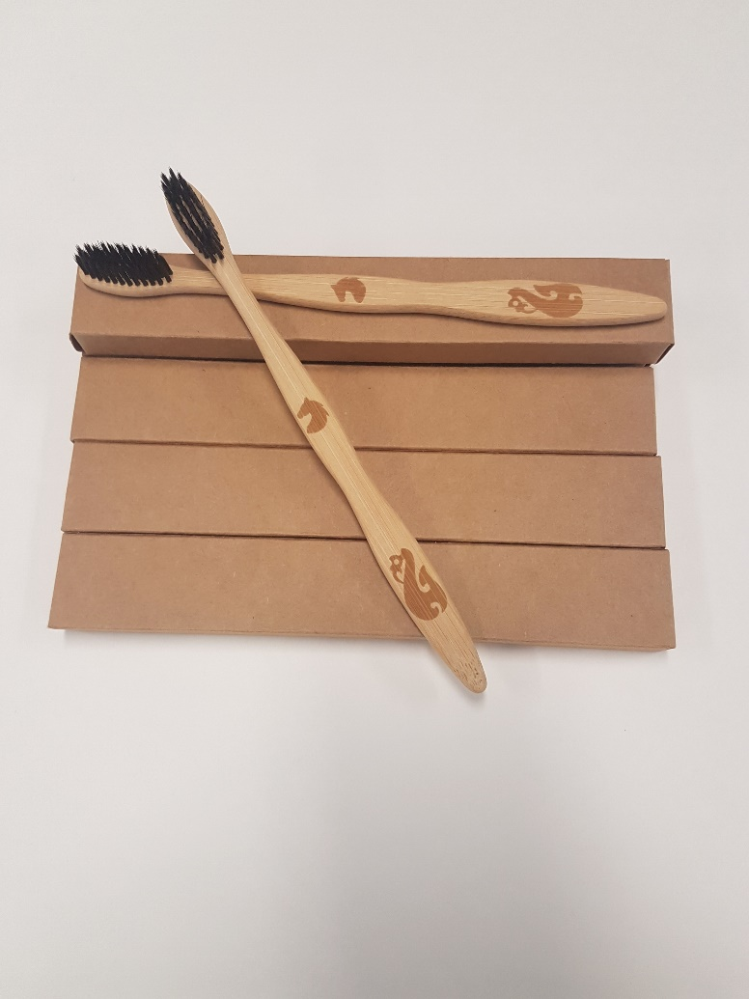Machine generated alternative text:
THIRTY WHITE HORSES 
TOOTHBRUSHES 

**There will be food and drink provided**

**Come along and buy our bamboo toothbrushes!**

**Indivdually $5 each**

**6 month subscription ranging from $12 to $28**

**Cash Only**

**Thirty White Horses**

**Product Launch 30th August**

**Location: MS1 & MS3**

**Time: Doors Open @ 6pm Presentations begin @ 6:30pm**