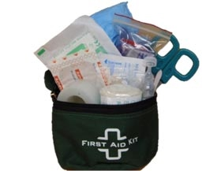

$15.00

**Mini Compact**

**20 piece**

**First Aid Kit**

Rugged Belt Mountable First Aid Pouch

120mm=Width x 80mm=Height x 45mm=Depth

Roll Clear Easy Tear Medical Tape

CPR Face Shield with one way valve

Sterile 5cm x 7.5cm Non Adherent Dressing

5cm x 4.5M Stretchy Cotton Crepe Bandage

15ml Saline Irrigation Ampule

Assorted Plaster Shapes

Rescue Shears (Scissors)

Steel Tweezers

Pair Medical Grade Nitrile Gloves

190mm x 110mm Antiseptic Towelettes

First Aid Tips