myKindo – coming to Glen Eden Intermediate!

We are excited to let you know that Glen Eden Intermediate will be using Kindo in 2022,
so if you already have a myKindo or ezlunch account at your current school, you can use the same account!
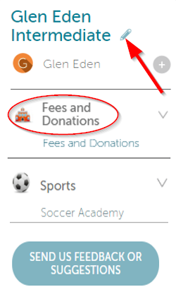
From mid January 2022 you can login to your current myKindo or ezlunch account, select my details to update your child’s school to Glen Eden Intermediate, and save the changes.

Then select the ‘Fees and Donations’ to link your student to our school records.

If you have children at two different Kindo or ezlunch schools, you can use the pencil to switch between the two schools and make your payments.

One myKindo account for both Schools – it couldn’t be easier!

New to Kindo? From mid January 2022 you can easily register here by simply entering in the email you have on file with Glen Eden Intermediate.

SAVE TIME – PAY ONLINE

