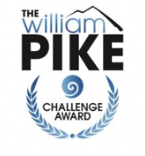

The three elements of the William Pike Challenge Award are Outdoor Activities, Community Service and Passion Projects. They provide exciting opportunities for our youth to step outside their comfort zone and develop and strengthen vital universal life skills. Here is an explanation of each element and how they help prepare our youth to overcome challenge and change.
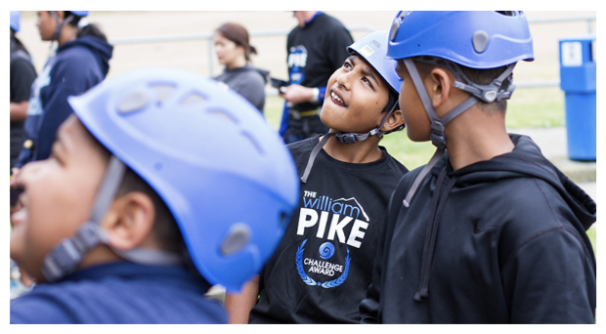

Our children are stepping into a rapidly and dramatically changing world. They will be challenged by unexpected changes and obstacles in life that we can probably yet imagine.
When big challenge and change comes, succeeding or failing comes down to one thing – whether you are already used to pushing yourself out of your comfort zone. That’s where the William Pike Challenge Award comes in.
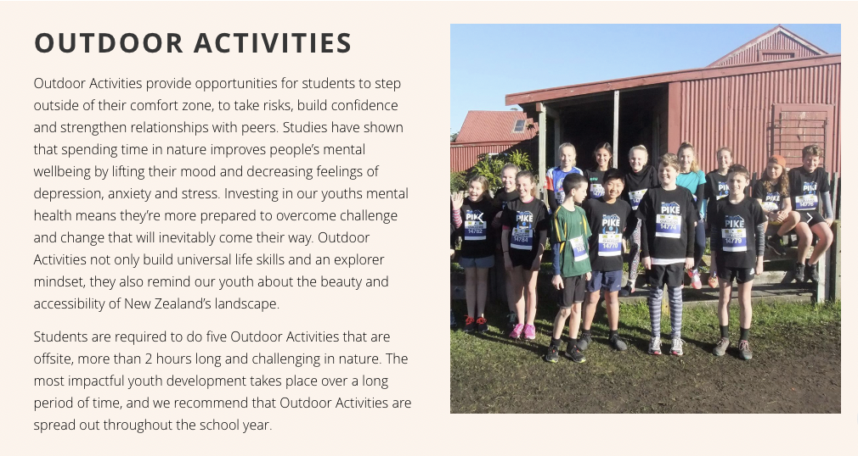
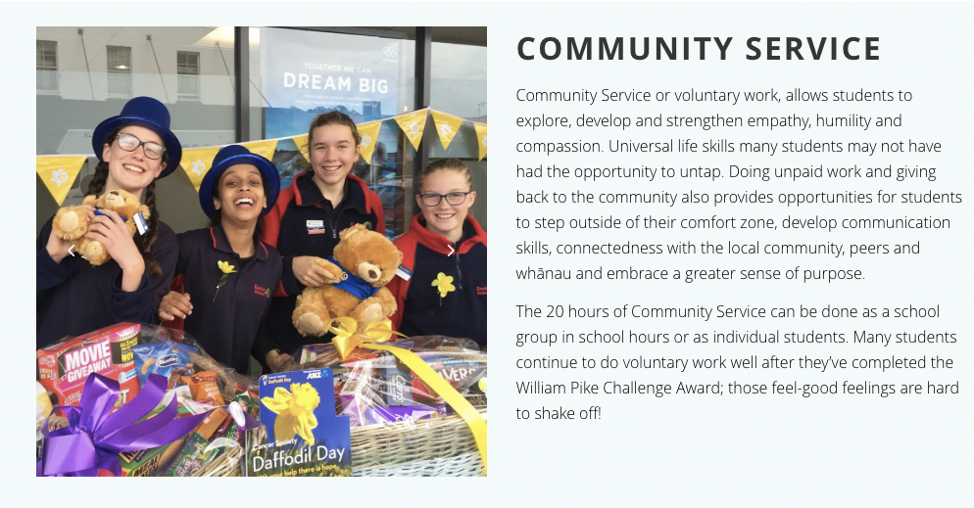

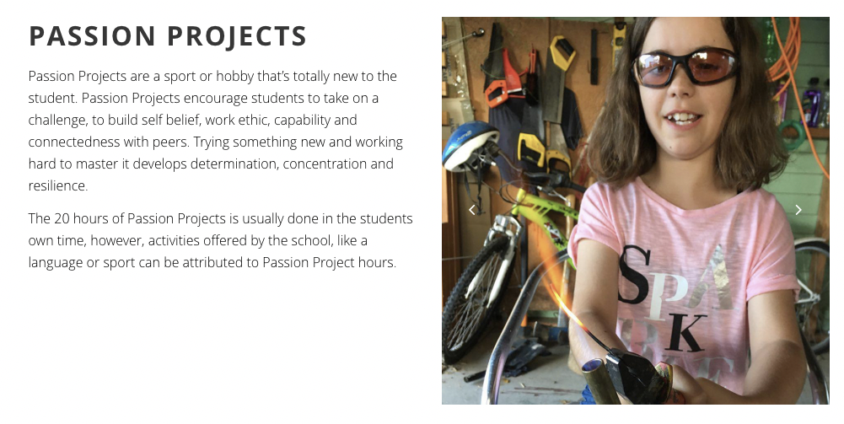The Key competencies of the New Zealand Curriculum sit naturally within the William Pike Challenge Award programme, particularly; self-management, relating to others and participating and contributing. Students have opportunities to develop, practise and demonstrate these in a range of authentic contexts.
The Challenge Award complements our ‘Education Outside the Classroom’ (EOTC) programme, as well as supporting aspects of the Health and Physical Education curriculum area.
It’s these experiences and opportunities that prepare kids for the future in a very practical way - preparation that would not be possible in a classroom setting alone. A $40 fee hooks students up to the ‘Challenge Hub’ which provides teachers with a snapshot of students’ progress. It is also a great tracking tool for students who can upload photos, log their community service hours, and keep an online diary about their experiences as they complete the challenge award.
The Hub participated in the William Pike Challenge Award for the first time in 2020 and are excited to offer it again in 2021.

