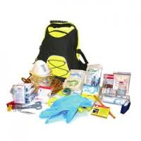

$141.00

**Back Pack - One Person 72hr Survival Kit**

First Aid Essentials Antiseptic Wipes

30ml Saline

7.5cm Bandage

Conforming Gauze 7.5cm

Triangular Bandages

Eye Pads

Safety Pins

Rescue Shears

Tweezers

First Aid Booklet & AIDS Info Sheet Notebook & Pencil

50 Pack Plasters

1M Dressing Strip

Medical Gloves

CPR Mask

Emergency Foil Blanket

Roll Paper Tape

Non Adherent Dressings

Wound Dressings

Emergency Poncho

Pair Leather Work Gloves

Hi Viz Vest

Dust Masks

10M Length Cord Rope

Pair Knitted Gloves

Disposable Ear Plugs

Dynamo Torch

Water Purification Tablets

Multi Function Knife

12hr Light Stick

Matches

Candle