14 September 2017

Dear Member,

Re. Notice of Annual General Meeting.

This report will be presented at the Annual General Meeting to be held at the Otago Chamber of Commerce offices at 442 Moray Place, Dunedin on Thursday 12 October 2017 at 12.30pm.

We hope you will be able to join us for the meeting and would appreciate your RSVP to ensure our constitutional requirements are met.

Please register either online at www.otagochamber.co.nz or phone your confirmation through on
03 479 0181.

Yours sincerely
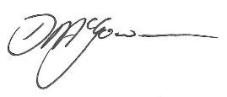
Dougal McGowan
Chief Executive

