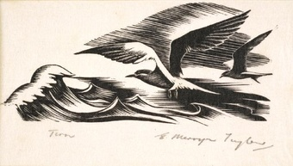
Tern
E Mervyn Taylor

Tern

I fly along the coastline, my sharp eyes picking out ripples in the choppy Tasman Sea. I swoop down and grab the herrings swimming near the surface. I flap my wings, quickly bringing me into the air again. I turn around under the darkening sky and propel myself towards New Zealand, the feathers on my wings blowing out behind me.
Streaking up to my nest, I shake out the salty sea spray on my feathers and pass one of the fish to my mate, who is currently incubating our egg.
Tomorrow I will take his place while he fishes, then we will swap. Everyday it will be the same until the egg hatches, then both of us can go and fish, though one will always stay close to protect our chick until it learns how to fend for itself.

By Katherine Rutter

