Bluestone School
Thanks to the below businesses for sponsoring our school app:

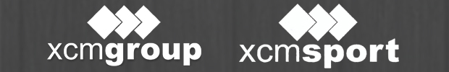
If you would like to advertise on the Bluestone School Skool Loop App please email Content@skoolloop.com

To download our app: In Google Play & App Store search
‘Skool Loop’ & choose Bluestone School once installed.

