**Have a go at Fencing!**

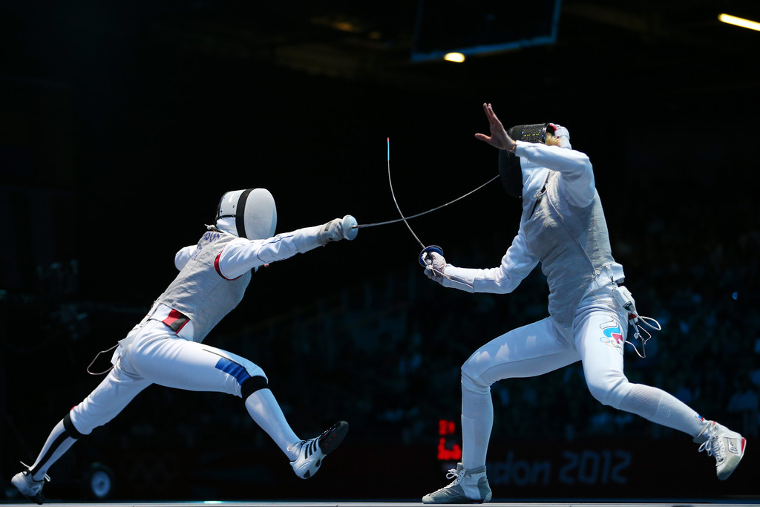

The next beginner’s fencing class for adults and children starts on Wednesday the 19th of February. This five-week course costs $80 including use of gear.

If you’ve always wanted to give fencing a try, email us at claymoreswordsclub@gmail.com   
for more information.