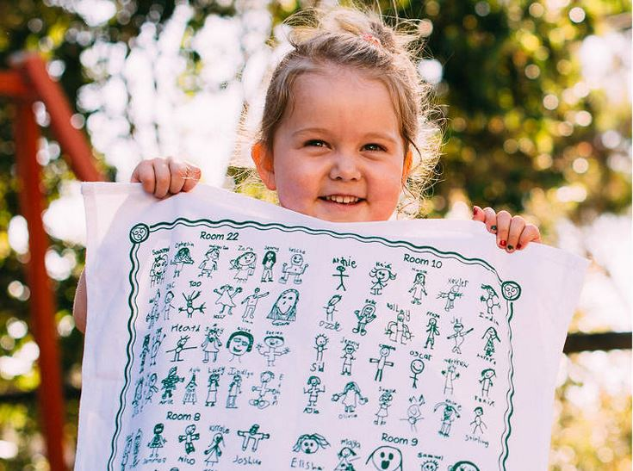
TEA TOWEL FUNDRAISER

Dear Parent/Caregiver

Knights Stream School School FoS is running a Tea Towel Fundraiser to raise money for our wonderful school.

Our students are designing the layout along with our teachers, and the Tea Towels will feature their artwork. The drawings will be screen printed onto high quality cotton tea towels over 500mm wide by 700mm high!

Tea Towels are a great way to feature the Children's own artwork and have them involved in the design of the Fundraiser. They make great gifts and are easily mailed to relatives, even overseas. The Tea Towels look great and are long lasting mementos of your Children's younger days. Not to mention that they are great for drying dishes!

By purchasing a Tea Towel(s) you are not only receiving a great keepsake or gift, you are also helping achieve our fundraising goals, which would not be possible without your support!

The price per towel is only $15 for 1, $20 for 2 And $10 for each towel after that!

The Tea Towel print run is limited so make sure you, your family and your friends don't miss out!
Fill out the order form below.

Final Order Cut Off:
If you have any questions you can contact fos@knightsstream.school.nz

TEA TOWEL ORDER FORM

Caregiver Name and Contact Number: ___________________________________

Student Name: ______________________________________________________

Class: ___________________ Quantity Requested: ___________________

Please make online payment only to
Knights Stream School FoS
12-3441-0102049-00
Reference: Childs name and Class

This form must be handed to the Tari (office) by Thursday, 7th November 2019

